**Analysis of Trajectory, Fate and Remedial Options for Potential Spill Scenario at the Gullfaks (Platform C) of the North Sea**

**by**

**Douye Victor Orumieyefa**

**January 2021**



**RESEARCH DECLARATION**

I declare that this thesis is entirely my own work and that any use of the work of others has been appropriately acknowledged as in-text citations and compiled in the reference list. I also confirm that the project has been conducted in compliance with the University’s research ethics policy and evidence of this has been included in my thesis.

I agree that the project thesis can be made available as a Reference Document for other students in the School of Energy, Construction & Environment Information Room/Map Library.

Signed: Douye Victor Orumieyefa Date: 03/01/2021

**ABSTRACT**

Oil spill footprint remains a significant contributor to environmental degradation and loss in biodiversity, therefore, represents a major concern to global sustainability. Furthermore, increasing demand and transportation of crude and its products have heightened the frequency of spill occurrences globally. The Gullfaks C platform is a production, processing, and drilling platform and the most recent of the three large CONDEEP structures of the Gullfaks field. Significant studies undergone in the North Sea and other coastal environment coupled with recent developments in the Gullfaks platform C suggests the importance of an updated stochastic model for oil spill simulation in the Gullfaks C platform. The study hence aims to provide a stochastic model for a potential oil spill event in the Gullfaks C production/storage facility in order to provide an insight of the fate, trajectory, and possible response options (if needed) for the Gullfaks C platform given certain environmental conditions. The GNOME and ADIOS2 models were employed to forecast the trajectory and fate processes of the spilled oil in the Gullfaks C. Best Guess Solution and Minimum Regret Solution suggest a spill travel distance of 145km and 175km respectively and indicated a zero percent beaching outcome. GNOME results suggested the formation of Langmuir streaks and Windrows during the 5-day modelled duration of the spill. Oil loss due to evaporation was 24% and 27.5% for winter and summer periods, respectively. Formation of stable emulsions commenced after 36 hours of spill for both winter and summer periods. Air borne benzene concentrations fell from 30ppm to 1ppm within the first 14 hours of spill. The use of chemical dispersants is advised to avert potential oil footprints on resources.

**TABLE OF CONTENT**

**Abstract**

**Acknowledgements**

**Introduction**

* 1. **Background**
  2. **Research Gap**
  3. **Research Aim and Objectives**
  4. **Thesis Organization**

**CHAPTER TWO - LITERATURE REVIEW**

**2.1 Oil Spill Cases and Accidents**

**2.2 Review of Spill Models**

**2.3 Spill Trajectory**

**2.4 Fate Modelling**

**2.5 Transport and Weathering Processes**

**2.5.1 Spreading**

**2.5.2 Advection**

**2.5.3 Diffusion**

**2.5.4 Evaporation**

**2.5.5 Emulsification**

**2.5.6 Dispersion**

**2.5.7 Dissolution**

**2.5.8 Photo-oxidation**

**2.5.9 sedimentation**

**2.5.10 Biodegradation**

**2.6 Chapter Summary**

**CHAPTER THREE – METHODOLOGY**

**3.1 Study Area**

**3.2 Research Design**

**3.3 Data Type and Sources**

**3.3.1 GNOME Model**

**3.3.2 HYCOM**

**3.3.3 ADIOS2**

**3.4 Trajectory and Fate Modelling Procedure**

**3.4.1 Oil Spill Trajectory Simulation**

**3.4.2 Oil Weathering**

**3.5 Chapter Summary**

**CHAPTER FOUR – DISCUSSION AND ANALYSIS**

**4.1 Oil Spill Trajectory Analysis**

**4.1.1 Minimum Regret Analysis**

**4.2 Weathering Analysis**

**4.2.1 Evaporation**

**4.2.2 Emulsification**

**4.2.3 Viscosity and Density**

**4.2.4 Dispersion**

**4.2.5 Airborne Benzene Concentration**

**4.2.6 Sedimentation**

**CHAPTER FIVE – CONCLUSIONS AND RECOMMENDATIONS**

**5.1 Conclusion**

**5.2 Recommendations**

**REFERENCES**

**APPENDICES**

**List of Tables**

Table 1: List of popular spill models and associated characters

Table 3.1 Vertical Mixing options used in HYCOM

Table 3.2 Environmental and Spill Input Parameters

Table 3.3 Environmental and Spill Input Parameters for ADIOS2

**List of Figures**

Figure 1.1 Pictorial Illustration of the Gullfaks C

Figure 2.1 Relationship between Spreading time and Spreading area

Figure 2.2 Wind and Current Contribution to slick movement

Figure 2.3 Evaporation curves for different oil types

Figure 3.1 Study Area

Figure 3.2 Physical and Chemical Changes following oil spill

Figure 3.3 Component Diagram for ADIOS2 Model

Figure 4.1 GNOME analysis of Gullfaks Platform C oil Spill Trajectory

Figure 4.2 Ocean Current Obtained from HYCOM

Figure 4.3: GNOME Model without wind

Figure 4.4: GNOME Model with wind

Figure 4.5: GNOME Analysis without Turbulent diffusion

Figure 4.6: GNOME Analysis with Turbulent diffusion

Figure 4:7 : Gnome splots with minimum regret solution

Figure 4.8 : GNOME splots without minimum regret solution

Figure 4.9 : Evaporation during Winter at 46◦F

Figure 4.10 : Evaporation during Summer at 64◦F

Figure 4.11 : Emulsification during Winter at 46◦ F

Figure 4.12 : Emulsification during Summer at 64◦ F

Figure 4.13 : Density during Winter at 46◦ F

Figure 4.14 : Density during Winter at 64◦

Figure 4.15 : Viscosity during Winter at 46◦ F

Figure 4.16 : Viscosity during Winter at 64◦ F

Figure 4.17 : Dispersion during Winter at 46◦ F

Figure 4.18 : Dispersion during Summer at 64◦ F

Figure 4.19 :Airborne Benzene during Winter at 46◦

**ACKNOWLEDGEMENT**

I Would like to express my profound gratitude to God Almighty for the success of this work. I remain privileged and forever grateful to my beloved parents, Mr and Mrs Henry and Grace Orumieyefa for their support throughout this work. A deep sense of gratitude goes to project supervisor, Dr Babatunde Anifowose.

**CHAPTER ONE**

**1.0 INTRODUCTION**

**1.1 BACKGROUND**

Owing to the now global clamour for sustainable practice in the oil and gas sector with keen reference to the United Nations Sustainable Development Goals (SDGs), the subject of environmental degradation and biodiversity loss represents major milestones to be accomplished if the SDGs are to see the light of day. Seated at the epicentre of the subject, the voluntary and accidental release of crude oil into the environment brings into perspective, the dramatic footprints it poses on the environment. Furthermore, with the increasing demand for petroleum products, coupled with marine transportation, the frequency of oil spills offshore has been aggravated as demand for crude increases (Spouge 2019). Despite the global zero-carbon movement and thus the recent propaganda for renewables (Arent et al. 2011; Biswas et al. 2011; IEA 2020), world global petroleum production is estimated to increase by 5.7mb/d before 2025 following a sharp rebound in 2021 (IEA 2020).

The 11-million-gallon spill of crude oil in the catastrophic Exxon Valdez spill during the late 1980s was recorded as one of the most severe human-caused environmental disasters of all-time (Lee 2012). According to Lee (2012), the event received extensive attention globally, laying emphases on the need for an emergency response system for oil spill scenarios which have been deemed inevitable given the continuity of petroleum operations. Similarly, Spaulding (2017) in agreement with Ribotti et al. (2019) posed that the success of any spill mitigation action is directly related to the time required for the detection of the slick and further produce a model simulating its transport and fate. The above premise implies the urgency for a stand-by oil response plan for areas with prospective spill occurrence.

The operational profitability of the Gullfaks C platform (see Figure 1.1) has been proven by Equinor as deemed by the Norwegian Petroleum Directorate (NPD 2019). The offshore platform will thus continue operations until 2036 as provided by the Norwegian Agency (NPD 2019). According to HSE (2001) regulations on design lifetime, further operations on the three-decade old facility poses human and environmental risks including a prospective major spill. This implies that the current and future production on the platform is a potential hazard, thus deemed risky (Hauge et al. 2013). Furthermore, Equinor (2010) in agreement with PSA (2016) carried out an investigative report on an earlier curtailed occurrence of a leak on the platform with capacity to result in a major blowout and thus spill. This may be related to latent failure given the aging of the storage and production facility PSA (2016).

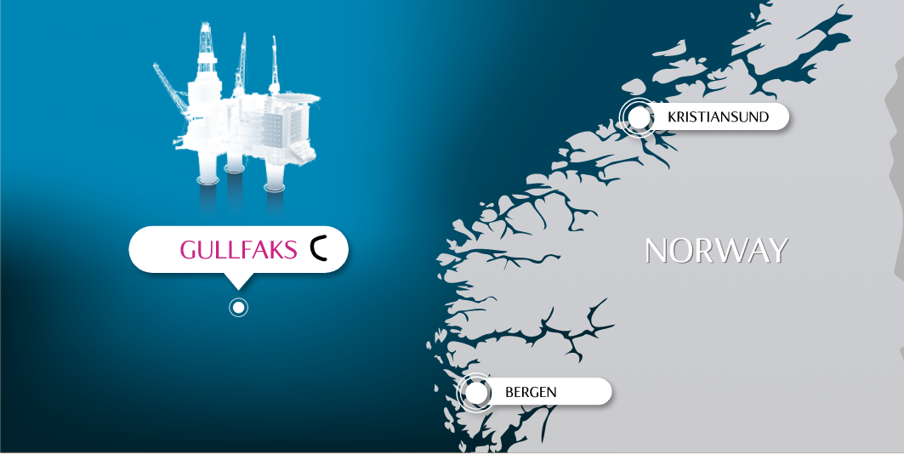

Figure 1.1 : Pictorial illustration of the Gullfaks C (Equinor 2020)

**1.2 RESEARCH GAP**

Studies regarding the trajectory and fate determination of oil slicks around the Gullfaks and other coastal settings have been carried out ( e.g., Afenyo et al. 2017; Al-Rabeh, Cekirge, and Gunay 1989; Arzaghi et al. 2018; Beegle-Krause 2018; Chen et al. 2019; Eke and Anifowose 2017; Fraser and Racine 2016; French-McCay et al. 2018; Zhen et al. 2020). The above studies have identified gaps in previous works carried out in the North Sea and a host of other environs. More so, none of the research reveals recent specific insights on spill trajectory, fate, and remedial avenues for the Gullfaks platform C - a currently active production platform of the Gullfaks field operating beyond its original design lifetime (OGJ 2019). This will thus represent the research gap for this study. The resolve of this study is therefore to provide an up-to-date simulation of the transport path and fate of a potential spill scenario in the C platform of the Gullfaks operational field and subsequently propose recommendations for future works.

The data source to be adopted in the study will be secondary. The methodology involves a spill transport trajectory with an inclusion of minimum regret for uncertainty reduction using the GNOME modelling environment. The study will also include the weathering analysis of physical and chemical parameters with the aid of the ADIOS 2 model.

**1.3 RESEARCH AIM AND OBJECTIVES**

The study hence aims to provide an updated stochastic model for a potential oil spill in the Gullfaks C production/storage facility. This is achievable given the success of the underlying objectives:

1. To simulate and predict the trajectories of the spilled crude using the General NOAA operational Modelling Environment (GNOME) software.
2. To reduce trajectory uncertainties using the “minimum regret” option.
3. To simulate the fate of the oil using the Automated Data Inquiry for Oil Spills (ADIOS2) software in winter and summer periods.
4. To provide recommendations for the potential spill scenario and future work.

**1.4 THESIS ORGANIZATION**

Chapter 2 provides a detailed literature review encompassing historic oil spill occurrences and accidents, spill model review and comparison as well as an appraisal of trajectory and weathering processes.

Chapter 3 describes the methodology carried out in this research project.

Chapter 4 presents the results obtained from the transport and weathering analysis using the GNOME and ADIOS2 models and provides detailed discussions for the implications they may pose.

In chapter 5, the overall conclusion for this study as well as recommendations are provided.

**CHAPTER TWO**

**2.0 LITERATURE REVIEW**

Petroleum spills have destroyed ecosystems around the globe. As a result of its hazardous impacts on marine life, the subject represents a major reason for concern. Prior this time, flurries of significant studies have been carried out in a bid to model the movement and direction of oil slick as well as fate of the trajected spill in the North Sea and other coastal settings.

**2.1 OIL SPILL CASES AND ACCIDENTS**

Improvements in oil spill response strategies globally are directly related to a number of large-scaled oil spill occurrence in the past (NOAA 2020). More so, an understanding of past spill cases may bring reasonable insights to the response and remediation of prospective cases similar in magnitude and character.

Frank, Costle, and Schneider (1978) presented a preliminary report for the 1978 Amoco Cadiz spill. According to the report, the tanker ran aground following an assumed failure in the steering gear. Approximately 64, 000 metric tons of oil (one-third of total tanker capacity) was spilled along 72km stretch of shoreline in the first 2 weeks of spill. Furthermore, about 84% of the grounded oil on shoreline was reduced due to. Natural dispersion and clean-up activities are likely deductions for this occurrence. In contrast, the amount of visible shoreline contaminated rose to 320km on subsequent observations. This could be as a result of dispersion and break-down of oil masses by current and wave action. This is evident as there was a significant change in wind direction from a west to easterly orientation (Bellier and Massart 1979)

Horn and Neal (1981) provided a report on the Atlantic Empress collision spill in the Caribbean Sea. The fiery accident resulted in the death of 27 crewmen and a release of over 3.5 million barrels of crude oil. Findings have indicated that that no oil reached the shoreline, thus there was no real environmental implication (e.g., Edwards and White 1999; Horn and Neal 1981). The reduced environmental implications could be due to insitu-burning which dropped the concentration of oil on water (NOAA 2019).

The Exxon Valdez tanker ran aground on 24th March 1989 in Prince William Sound, Alaska resulting in the release of over 42 million litres of crude (Esler et al. 2018). Monson et al. (2000) appraised the long-term impacts of the Exxon Valdez spill scenario using age-reliant mortality patterns on sea otters. Results showed a trend of decreasing mortality rates in the years following the event while animals existing before the spill showed maligned impressions. This implies an alteration in the marine living conditions, thus increasing susceptibility in organisms. Similarly, Esler et al. (2018) stated that chronic spill effects due to the Exxon Valdez spill have persisted for over two decades and have altered population dynamics in the long term. Following the 1989 Exxon Valdez the call for spill mapping expertise drew much attention and thus favoured the development of Water-Based Oil Spill Modelling Software (WOMS) (Lee 2012).

Michel (2011) surveyed the Gulf War Oil Spill event in 1991. The study revealed that most of the 11 million barrels of oil was trapped along the shoreline in the Abu Ali Island, and in the northern regimes of Jubail, Saudi Arabia. According to conducted study on the Impacts of the spill, an estimated 1,163,000 barrels of crude oil was retrieved from the gulf following spillage. The slick was persistent as It encroached over 40cm in the burrowed sand and mud intercalations. This could be related to the viscosity of the crude and thus. The survey revealed the absence of all forms of living epibiota and halophytes in the intertidal zone twelve months following the spill. A limitation to this study lies on the fact that pre-spill information on the ecological state of parts of the gulf are insufficient and thus will not support pre-spill and post-spill assessments.

Martinelli et al. (1995) assessed the 1991 Motor Tanker Heaven spill in 1991 in Genoa, Italy. The spill involved the release of over 145,500 metric tons of Iranian heavy crude along the coastal Ligurian Sea. Results from the study indicated that the spilled oil persisted into the seabed and deep-sea benthic community. This is related to the oil type (heavy crude). However, the study also posed that fate processes may reduce the overall slick effect on sea-bed habitats and their resources, though the residual oil may be present in trace amounts over a few years. The processes for the spill clean-up commonly available in coastal environments (tide, wave, and biological degradation) are not significantly present in the Ligurian Sea. This implies that a total restoration to of the environment to its original state may prove abortive.

Shultz et al. (2014) provided an Established Trauma Signature (TSIG) procedure to assess the psychological implications from the Deepwater Horizon oil spill in 2010. After a well blowout that destroyed the platform, 4.9million barrels of crude oil covering approximately 68, 000 square kilometres was released into the Mexican gulf. The impact of the spill was heightened due to previous exposure of the area to Hurricane Katrina. Smith, Smith, and Ashcroft (2010) posed that total damages to the British Petroleum (BP) company, US gulf coast economy and the environment was to the tune of $36.9 billion. The study attributed the damages to a number of factors including Equipment failure and human error, failure to assign permit by the US govt and misinformation amount and location of the spill location.

**2.2 REVIEW OF SPILL MODELS**

With continuous occurrences in oil spill cases, studies regarding the fate and transport processes have been carried out on the basis of mass balance approach and the trajectory method. Some detailed review of a number of spill models have been given. Generally, they include GNOME, OSCAR, BLOSOM, ADIOS, OILMAP etc.

Duran et al. (2018) compared the operational performance of the Blowout Spill Occurrence Model (BLOSOM) and the General NOAA operational Modelling Environment (GNOME) on a point well oil spill scenario. The presented simulations are forced using a Finite Volume Community Ocean Model (FVCOM), exceptional in tidal and wind data representation. According to results, beyond several similarities, distinctive aspects of both models such as beaching algorithm, release period, diffusion coefficient, etc are highlighted. This is largely due to the addition of an internal angle of deflection for advection parameterization. Suggested options for improvement of the modelling environments is the inclusion of a temporal force field interpolation (BLOSOM) and the inclusion of an angle of deflection for wind-driven cases (GNOME).

Largely due to the variations of the structure and build-up of simulation systems, different spill model results from a spill scenario may show some dissimilarities even with the same input (Zheng and Labrador 2017). Zheng and Labrador (2017) compared two widely used models (OSCAR and GNOME) in the Newfoundland offshore area. GNOME and OSCAR were used to simulate the transport and fate of the oil slick. Current data from the Hybrid Coordinate Ocean Model (HYCOM) and surface wind data from the National Climate Data Centre (NCDC) catered for advection. Results from the GNOME simulation showed that 43% of released oil was dispersed during the first 48hours while the OSCAR model indicated the evaporation of about 87.4% of released oil. While the OSCAR modelling tool showed better results for the weathering processes, the GNOME simulations displayed a more feasible match with RADARSAT-1 satellite image observations in terms of spill location, shape, and spill plume.

Elizaryev et al. (2018) analysed the GNOME/ADIOS and the HAZMAT spill simulating model using the Exxon Valdez spill scenario. According to results from the simulation, the early days following the release showed insignificant differences. Following the seventh day after the spill, the HAZMAT model was seen to have extended a longer distance as compared with the GNOME model. Possible deductions for different output data could be due to the use of different weather data sources and also trajectory difficulty in a storm. Conclusions as regards to the fate of the oil slick were somewhat similar for both systems (ADIOS and HAZMAT) as simulated results revealed that changes in physical and chemical character of the slick began after the first 10 hours as evident in the evaporation, viscosity, and dispersion graphs. This could be due to a change in the weather conditions of the area.

Nelson and Grubesic (2018) provided a progress report on oil spill computational tools, emerging technologies, and mathematical frameworks in oil spill modelling (see Table 1). According to the study recent advancements in spill modelling packages includes the addition of dispersant applications to the plume as exhibited by the BLOSOM and SIMAP/OILMAP environment. Advancements in GNOME includes the addition of the ADIOS fate simulating tool, Incorporation of a three-dimension modelling system, deep water trajectory system and a blowout model geared towards the improvement of response efficiency (Lehr et al. 1992; Zelenke et al. 2012). More so, The OSCAR simulating system also receives regular updates as regards to the oil transport in water column coupled with the addition and refinement of modelling, proving useful in contingency processes (SINTEF 2018).

Table 1: List of popular spill Models and associated Characters (Nelson and Grubesic 2018)

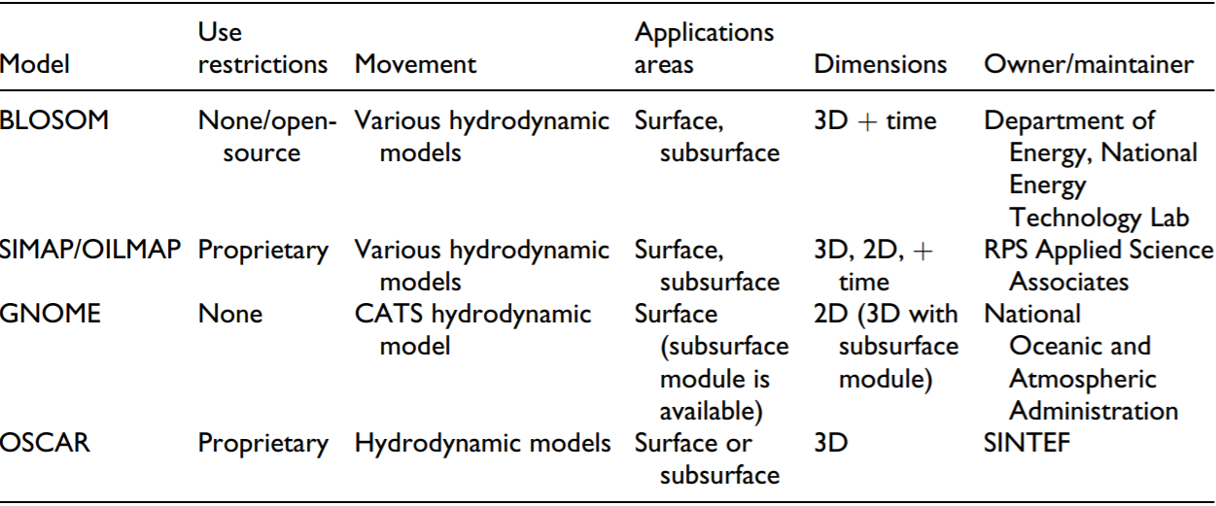

De Jong (2004) presented a report following the comparative study of four trajectory and fate models (DemWaq developed by RIKZ, DREAM by Sintef and GNOME by NOAA). The study aimed to aid in the selection of a suitable transport and fate model in the prediction of the distribution of spills in coastal areas as well as along the continental shelf. According to De Jong (2004), the aspects of the simulating systems compared were concepts and character of model, discoveries from experiments and model functionality. Though the study implied a limitation on the GNOME model as evident in its simplicity, more recent studies by Spaulding (2017) indicated a notable improvement of the modelling environment with the incorporation of a fate modelling character ADIOS. More so, De Jong (2004) highlighted its user-friendliness, easy accessibility, and an addition of the minimum regret option in the GNOME interface as compared to the other three particle models.

The GNOME ‘best estimate’ tool illustrates the modelling results, with the assumption that all imputed data are correct. As this is rarely accurate for any computer model, the ‘minimum regret’ tool has been incorporated in GNOME to account for uncertainties that may rise such as fluctuations in current and wind readings (Spaulding 2017). In a number of cases, sections within the minimum regret solution may be susceptible to oil spills, therefore worthy of accountability. The GNOME Model simulates a wide variety of pollutants with high API variations, incorporating the Langarian and Eulerian elements.

The Automated (ADIOS) is a fate modelling system developed by NOAA. The system incorporates about one thousand oils (based on location and API) to accurately account for the quantity of oil and duration the duration of time the spilled slick will stay present in water. Calculations in ADIOS involves the integration of environmental (e.g. wind speed), chemical and physical property data. The program is dependent on temperature variations as it provides output on parameters such as evaporation, density, viscosity, and oil dispersion in water.

**2.3 SPILL TRAJECTORY**

With increase in oil spill cases offshore, and consequently their impacts on surrounding environments and life forms, it has become expedient to track the movement and direction of an oil once spilled.

Eke and Anifowose (2017) trajected slick movement in the Clair Oil Field of the North Sea. The Gnome modelling environment was used to simulate the movement and direction of the slick in the Faroe-Shetland Channel. Minimum regret analyses revealed a prospective encroachment of the slick into the Norwegian coastline given that persistence is favoured. An implication of this study to the Gullfaks C prospective spill will be a similar behavioural pattern given the proximity of both fields (Clair and Gullfaks).

Zhen et al. (2020) appraised oil slick drift in the Daya Bay of South China using a two-dimensional shallow water equation. Results showed that the pollution area of spill under clockwise residual flow is larger than the anticlockwise flow. This implied that an oil slick will generally be propagated more in the wind and tidal directions. A similar study was carried out by Saad and Hamzi (2016) in the Skikida Port Trajectory of oil slick demonstrating that oil slick transport is greatly dependent by the wind and diffusion coefficient.

Bassey et al. (2017) forecasted oil slick propagation of medium light crude in south eastern Asia using the Gnome model, putting into consideration a risk assessment of prospective impact areas using ESI maps. Final scrutiny of the results implied a beaching outcome on the ninth day, hence the need for immediate response.

Badejo, Folarin, and Anwanane (2014) Simulated oil spill trajectory of 6 FPSOs across offshore Nigeria. They identified for both wet and dry seasons that oil slick speed generally increases from deep sea to shallower areas ranging from 10km to 20km from shoreline. A justification for this premise was the influence of tides which is more dominant in the 10 - 20km region as opposed to low tides further offshore. Likewise, Spaulding (2017) proffered the integration of high frequency radar (HFR) for shallower waters to aid in the determination of the upper water bound coefficient.

Xu et al. (2013) correlated the Synthetic Aperture Radar (SAR) Satellite images with Gnome oil slick model in the Bohai Sea. The study attested that operational wind and current are useful in running of the spill model. The results indicated that the extent of spilled oil as denoted by the splot number is a crucial factor for Gnome stability given that the splot number is less than 500. He further implied that satellite incorporation with Gnome model remains a vital factor for the creation of the initial model conditions.

Bozkurtoğlu (2017) developed a hydrodynamic model in a bid to investigate prospective risks of accidental spill occurrences in Bosphorus. The model incorporated current velocity data at the surface with the surface dominant advection, evaporation and spreading mechanisms. The study included the determination of fourteen high accident risk locations. Results from model simulations implied that oil slick encroaches into the shoreline < 4h after the initial oil release. This finding implies that the spilt oil will impact both the Asian and European coasts respectively if timely intervention techniques are not applied.

(Qiao et al. 2019) established a three-dimensional oil spill model to mimic short and long duration trajectories following the Sanchi wreckage and spill. Surface wave data, wind and ocean currents where used in tracking slick particles up to 180 days following the Sanchi leakage. There was a high level of conformity between the short-term simulations and the SAR satellite imagery reports. A number of coastal areas including the Ryukyu Island are likely to be affected by at least 30% of the spilled bunker oil. The study stresses the relationship between the contaminated coast and the surface wind. Regional confinement of the polluted area was attributed to rapid evaporation of the condensate. More recently, (Li et al. 2019) stressed the importance of uncertainty analysis to increase the accuracy of the released time in the Sanchi spill. Both reviews accentuated the vitality of wind and current data on the slick trajectory model, attributing the simplicity of the wind field structure to the flat ocean surface.

(Afenyo et al. 2017) carried out an ecological risk model for marine oil spills from a probabilistic reference point. It was discovered that the results obtained where mainly estimates as only released spill information are mostly accounted for. A logical deduction to this end could be due to the fact that the physical properties may be partially characterised or more still, not understood.

**2.4 FATE MODELLING**

After spillage of an oil body at sea, it will religiously spread out from the source, moving on the surface of the water body while undergoing some physical and chemical alterations. These alterations and processes are collectively termed weathering, and they determine the fate of the slick (ITOPF 2018). A number of studies have been undergone in a bid to decipher the fate of spill cases.

Arzaghi et al. (2018) developed a novel methodology for the stochastic fate modelling of oil released from pipelines in the subsea of artic regions. The estimation of time-variable oil concentration was carried out by level IV fugacity models and Markov Chain Monte Carlo simulations. This allowed the integration of the uncertainty concomitant with other influencing parameters. Results indicated a quick decrease in concentration of oil within the first couple of hours. This proposed frame can aid the prediction of a concertation profile of slick released during an emergency scenario accurately through the consideration of dependencies on input factors.

Nazir et al. (2008) integrated a fate modelling approach in marine oil spill modelling. The study illustrated that the water compartment reaction to the chemical character input is quicker when compared to the sediment compartment. A deduction to this effect will be that it is due to the fact that the advection processes comes into play only in a water medium.

The fate of the January- February 2018, Sanchi oil spill as simulated by Pan et al. (2020) was achieved through the coupling of an oil spill model with satellite observations. The study carried out some extensive validation tests on oil fate and consequently comparing the different fates of heavy oil in the accident. Environmental forcing and model parameters were considered by a sequence of hindcast experiments. The study showed that the high viscosity heavy oil had a long simulation lifetime when compared to the light less-viscous oil. This feature is related to the quicker evaporation of the less dense oil, hence their short-perceived lifetime in the simulation.

Beegle-Krause (2018) assessed general principles and challenges in oil spill fate modelling. The study highlighted the spatial implications of oil density and composition. It stresses the role scenario (leakage, pipeline break, blowout etc.) and dynamics to future location of the slick. The study finally suggested the expedience of transport mechanisms in drift questions involving chemical releases, shipping containers etc.

Al-Rabeh, Cekirge, and Gunay (1989) formulated a comprehensive stochastic model of oil spill fate. The model consisted of a set of algorithms illustrating dispersion, emulsification, and evaporation of oil slick at sea. The algorithms are built independently linking related environmental processes. The results indicate that the model is capable of predicting the fate of oil with good accuracy. More scrutiny of the study shows that the accuracy of the model is limited to a relatively short period of time. This therefore renders the model inappropriate for spill scenarios demanding a longer time range.

Sebastião and Guedes Soares (1995) reviewed the main mechanisms affecting the fate of oil spills at sea. Different expressions have been proposed for their corresponding mechanisms. The study revealed that the model predictions were more effective and realistic than an individual computation from different authors. This strengthens accountability in process interactions

(Abascal et al. 2017) presented a local high-resolution operating forecast procedure for oil spill fate response in the Belfast Lough area. After a detailed validation and calibration of the system was carried out on the basis of observational data, a suiting methodology was proposed to aid the optimization of oil spill fate model performance. The results further showed that improving the meteorological forcing resolution will influence the accuracy of the fate simulations. Though the system has been made functional in the Belfast area, its application will prove useful in other coastal water bodies as well as the Gullfaks to enhance spill response.

(Chen et al. 2015) developed a Langrangian particle-tracking system to simulate the fate of an oil slick spilled in deep waters. The model consisted of the plume dynamic models and the advection diffusion model. The validity of the model is verified by comparing predictions from other observed field data. The fate of the oil slick is investigated after 48hrs of release in terms of its underwater distribution and budget. The results showed that only a small proportion of released oil is lost as a result of underwater dissolution. The study further shows the relationship between the depth of spill and fraction of oil remaining. An implication of this study is its application with different GOR scenarios. Thus, the presence of a gaseous medium has an influence on oil location and surfacing.

Similarly (Bock et al. 2018; French-McCay et al. 2018; Walker et al. 2018) developed an approach in order to carry out a Comparative Risk Assessment for a number of response options, which integrated predictions of an oil spill fate simulation using a unique system of calculating Valued Ecosystem Component (VEC) recovery time and exposure. The Comparative Risk Assessment was useful in evaluating a proposed offshore deep-water spill event so as to decipher an appropriate response style in minimizing ecological risks and reduce wildlife exposure to hydrocarbon compounds. The CRA system provides an objected metrics for the comparing different implications from response alternatives.

(Loh et al. 2019) Investigated the weathering of residual oils during remediation activities after 12 months following the Wu Yi San oil spill. Observations under the microscope shows that a reasonably large amount of suspended particulate matter were formed. Negative buoyancy in the OSA of >95% was followed by neutral and positive buoyancy to about <1%. A scrutiny of the chemical evaluation showed that residual oils represented the driving sedimentation factor of OSA. The results showed that the negative buoyancy was as a result of mechanical remediation.

**2.5 TRANSPORT AND WEATHERING PROCESSES**

Following the introduction of an oil slick to an aquatic medium, the final concentration (both qualitatively and quantitatively) is dependent on three main processes; Spreading, Advection (movement caused by wind and current factors), Turbulent diffusion and a number of weathering processes (Spaulding 2017).

**2.5.1 Spreading**

An important process in the movement of oil slick following its initial release on the water column is the spreading process (Lee et al. 2015). According to Fingas (2011a), spreading is the first process of slick transformation and is mostly driven by gravitational and oil-water tensional forces on the water surface. Fay (1969) added that the impact of gravity becomes negligible in relation to the interfacial tensional forces overtime. The rate of spreading of the slick is influenced by sea-bed relief/topography, wind, tides, water current, and nature of spilled oil (Dew et al. 2015; Lee et al. 2015; Wang et al. 2008). Similarly, it is unlikely for spilled to beach immediately in a confined water body but will undergo rapid spreading, to envelop large areas on the sea surface (Lee et al. 2015; Michel and Rutherford 2014). Contrary, Fingas (2011) stated that oil spread on the water surface is possible even with the absence of wind and current. Wang et al. (2008) posed that there is some relationship between the weathering process of an oil slick and the spreading area. This implies a decrease of the spreading area with time due to sinking, dissolution and evaporation. According to Fingas (2011), Following the spill of oil on the water surface, lighter oil fractions such as diesel, gasoline, light crude will generally form thin slicks as compared to heavier crude oils with thicker slicks. The relationship between area of spreading and time is illustrated in figure 2.2. The coefficient for spreading rate is used in the scaling of results to agree with field observations (Mackay et al. 1982; Spaulding 2017). Spreading generally comes to an end as the all the volatile components of the oil is lost, thus reaching minimum thickness (Fay 1969; Spaulding 2017).

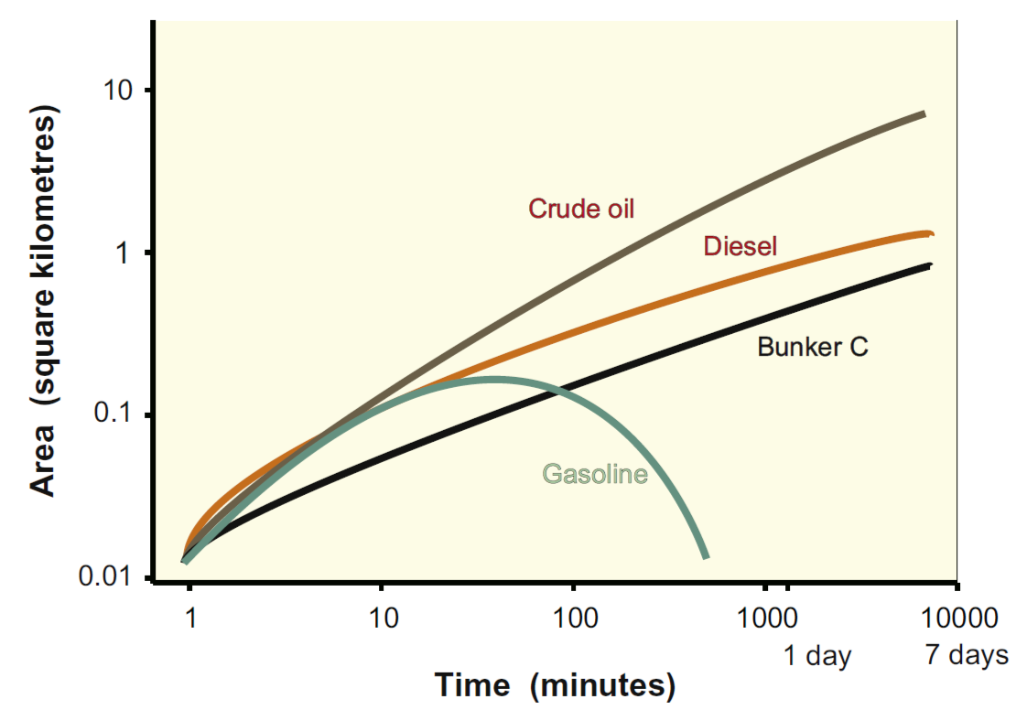

Figure 2.1: Relationship between spreading time and spreading area for different oil types.

**2.5.2 Advection**

As investigated by Fingas (2011), advection mechanisms (wind and current) increase the area on the water surface contaminated by oil. According to the investigation, the transport of spilled oil was largely influenced by surface currents in shallow areas with the speed of wind less than (<) 10km/h. In Contrast, wind influenced the oil transport when discharged in the open the sea with wind speed exceeding 20km/h. This implies the variations that exist in spill transport with changing conditions. However, Lee et al. 2015) an ideal situation demands that both wind and current mechanisms be considered in the determination of oil movement at sea. The foregoing premise could be due to the uncertainties governing oil transport. Leifer, Luyendyk, and Broderick (2006) stated that the oil slick velocity is equal to the sum of the vectors of wind and surface currents. Wind speed contribution to spill movement velocity ranges from 3-3.5% (Jens and Jacob n.d.). The effect of wind and current is illustrated in Figure 2.3. Fingas (2011) stated that water waves contribute to oil movement regardless of the relatively small effects of wave-induced movement mechanisms on spills (Jens and Jacob n.d.).

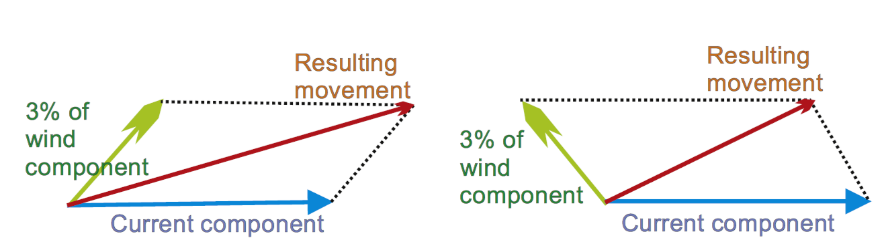

Figure 2.2

Wind and Current contribution to slick movement

**2.5.3 Diffusion**

They encompass both turbulent and pure diffusion processes by contaminant concentration. Compared to advective processes, Pure and turbulent diffusion involves a lesser space and time scale (Güemes et al. 2010). Güemes et al. (2010) stated the difficulty encountered in the simultaneous resolution of horizontal diffusion. This implies that the resolution must be precise, focussing on a singular time and space scale (Augusto 2016). The modelling of turbulence in an oceanic setting is a complex one and requires the use of complicated computer models (Augusto 2016). Augusto (2016) stated that a number of oil spill models employs the use of simplified formulas in mixing modelling. This is done by representing turbulent diffusion with a diffusion coefficient, usually the uniform and constant coefficients with strong basis on historical measurements. (Wang et al. 2008). Oceanic surface transport and spreading modelling in general is quite similar, depending on the given scenario (Wang et al. 2010). However, precision can be achieved with the application of Stochastic Langrangian Model (SLM), leading to a more concise representation of the physical processes affecting oil movement (Güemes et al. 2010).

**2.5.4 Evaporation**

Evaporation remains an important factor in the transformation of crude once it is spilled (Zheng and Labrador 2017). According to Zheng and Labrador (2017), over three forth and 40% of light and medium crude respectively could be evaporated after the first few days of an oil spill at sea. However, Aamo et al. (1997) explained that about 10% of spilled heavy oil is expected to evaporate. This implies a strong relationship between the density of crude and its evaporation. Due to its relevance on the spill mass balance, most spill models integrate evaporation as an essential component in their framework. Fingas et al. (2006) highlights the relationship existing between evaporation rates and temperature variations, implying that warmer days and seasons will generally experience higher rates of evaporation. More recently, Fingas (2011) stated that the rate at which an oil evaporates depends primarily on the composition of the oil. Figure 2.1 illustrates the different rates of evaporation of different soil types with the more volatile oil type evaporating more readily than their heavier counterparts. The volume of the evaporated fraction of oil is given in equation 2.1 (Stiver and Mackay 1984).

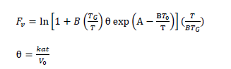 (Equation 2.1)

Where,

A and B are experimental data constants

T0 is initial boiling point

TG is boiling temperature curve slope

T = Ambient Temperature

Θ =Evaporative Exposure

K = Mass transfer coefficient

V0 is the initial spilled oil volume

a = area of spill

t = spill time

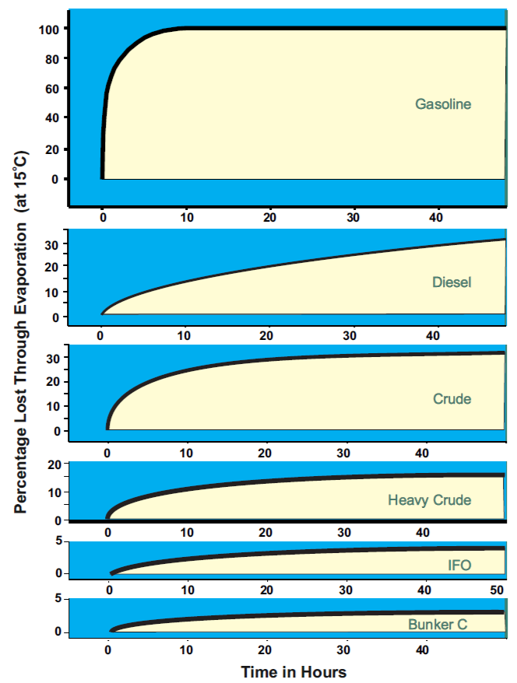

Figure 2.3: Evaporation curves for different oil types (Gasoline, Diesel, Crude, Heavy Crude, IFO and Bunker C) (Fingas 2011).

**2.5.5 Emulsification**

The energy carried by waves results in the mixing of seawater and oil, creating an oil-water emulsion in a process known as emulsification. On the basis of rheological measurements and water content, oil-water emulsions are grouped into unstable, entrained, meso-stable and stable types (see Appendix 2) (Fingas 2009). The different groups exhibit difference in their physical properties on formation of emulsions. This leads to a significant change in the physical properties of oil spills (Fingas 1995). Mackay et al. (1980) provided equation 2.3 for the emulsification process and have been applied by ADIOS and SINTEF models. (MacKay and Zargoski 1982) presented an exponential rise in water content, where the maximum water fraction incorporated is provided in the oil database.

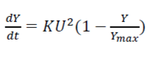 (Equation 2.3)

Where,

K = constant

Y = a Fraction of oil

Ymax = Final fraction

**2.5.6 Dispersion**

According to Fingas (2011), dispersion is the physical disintegration of oil slick on water surface to form droplets of oil and subsequently spread and diffuse on the water column. With exposure to waves and wind, oil at the water surface are able to disperse into droplets of oil (Stiver and Mackay 1984). Delvigne and Sweeney (1988) developed a dispersion model (equation 2.4) which has been adopted by the OILMAP, ADIOS and OSCAR models (Zheng and Labrador 2017).

 ( Equation 2.4)

Where,

Q = mass of oil droplets

Co = constant

De = Dissipating breaking wave energy

d0 =droplet size

Δd = Range in droplet size

Natural dispersion takes place when fine oil droplets are transferred into water by turbulence or wave action. Fingas (2011) implied that small droplets of oil (<20 mm) are more stable than larger droplets (>50mm). In the investigation report, he posed that natural dispersion is dependent on oil type and amount of sea energy available.

**2.5.7 Dissolution**

This process occurs when oil molecules dissolves into the water phase. Oil at its stable form can be dispersed and come into being smaller droplets of oil (micelles) (Berry et al. 2012). After spillage, Berry et.al (2012) stated that less than one percent of oil will be dissolved. There could be some variations due to different types of oil. Cohen et al. (1980) explained that a number of numerical models fails to account for the contribution of dissolution given its negligibility to the mass balance. The study further highlights the relative importance of dissolution as very toxic oil components are considered the most soluble, leading to serious biological effects even with low concentrations. Cohen et al. (1980) calculated the rate of dissolution

 (Equation 2.5)

Where

K1 = dissolution mass transfer coefficient,

fs = surface fraction covered by oil

As = slick area

S = solubility in water

So = solubility of fresh oil

a = constant

t = time

**2.5.8 Photo-oxidation**

According to Ganjali, Niknafs, and Khosravi (2007), the composition of an oil can change due to photo-oxidation. It occurs when carbon and oxygen in an oil slick combines to form new products such as resins due to the presence of sun light. If the resins and soluble and able to dissolve in water, they may result in the formation of water-oil emulsion (Fingas 2011). Some oil types are susceptible to the process while others are not (Ganjali, Niknafs, and Khosravi 2007). Due to its negligible effect on the immediate change of fate of an oil slick (Fingas 2011), it is not seen as an important process (Spaulding 2017). However, Wang, Stout, and Fingas (2006) argued highlighted the relevance of photo-oxidation to oil degradation which results in the formation of some oxidized compounds such as alcohols aldehydes and acids which have high solubilities in water.

**2.5.9 Sedimentation**

10-30% of oil slick will be absorbed and saved at the base of the ocean (Alsudais 2016). Most part of crude sedimentation takes place in the shallow waters and the limited waterfront realms with categorically richer particulates where water is subject to extra-ordinary blending (Williams & Odokuma 2014). This implies that in deeper zones, sedimentation of oil happens in relatively moderate proportions (Alsudais 2016). Zheng and Labrador (2017) provided an equation for the rate of oil loss due to sedimentation in equation 2.5 below.

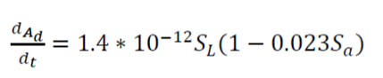 (Equation 2.6)

Where,

SL = sediment load

Sa = Salinity

For most spill simulation models the ratio of dissolved to adsorbed concentrations is calculated with the standard equilibrium partitioning theory, using the concentration of suspended particulate matter and a dimensionless coefficient (Spaulding 2017)

**2.5.9 Biodegradation**

The degrading of hydrocarbons by microorganisms into simpler and lighter compounds refers to biodegradation (Augusto 2016). Crude oil is a natural resource, therefore serves as a food source for some marine micro-organisms. However, biodegradation is a slow process as it relies on oxygen and nutrient availability, and absence of toxic pollutants. (Guemes 2010). The rate of biodegradation is dependent on some critical nutrient constituents such as iron, nitrates, and phosphates. An adequate supply of these components is relevant when large amounts of crude oil is spilled (Atlas and Hazen 2011). Secondary factors affecting biodegradation includes dissolved oxygen, temperature, spill area, salinity, and microbial character (Atlas and Hazen 2011; Gertler et al. 2012; Güemes et al. 2010).

**2.6 CHAPTER SUMMARY**

Significant studies have been undergone to model the fate and trajectory of oil spills across the North Sea and other coastal terrains. The study provides a report of the historical oil spill cases such as the Exxon Valdez, Deep water, and Motor tanker spill which have led developments in spill modelling. This chapter reviews a number of spill models such as the GNOME, OILMAP, OSCAR, BLOSSOM and ADIOS in terms of performance and accessibility. The study reviews fate and trajectory studies relevant in magnitude and character as well as transport and fate processes that may apply to the GULLFAKS C spill scenario. Based on the given literature review, the knowledge gap which represent the subject of this study have not been explored.

**CHAPTER THREE**

**3.0 METHODOLOGY**

**3.1 STUDY AREA**

The Gullfaks field is an oil and gas field located in the Norwegian sector of the North Sea and is operated by Equinor since its discovery in 1978 (Equinor 2020; Nordås 2000). The field is located between latitude and longitude 61°12′53.80″N and 2°16′25.93″E respectively (see Figure 3.1) in block 34/10, with water depth ranging between 130-230 meters (Nordås 2000). However, due to the proximity of the Shetland Islands, Stavenger, Bergen and Aberdeen areas to the field, a wider latitude (56.5°N-63°N) and longitudinal boundary (2.5°W-7.5°E) have been applied to this study. Since the discovery of the Gullfaks, the field has been developed into three (3) concrete-based facilities (Gullfaks A, B and C) which drill, process, and accommodate oil and gas from the field and adjacent fields (Norwegian Petroleum Directorate 2020). The Gullfaks C is the most recent of the three large Concrete Deep-Water Structures (CONDEEP) of the Gullfaks field. The height of the structure is over 370m (from skirt to shaft) with the base measuring over 160,000m (Svensvik and Kepp 1989). The area has a wind speed of 15knots and 22knots for summer and winter periods respectively (Furevik and Haakenstad 2012). The surface water current and salinity of the Gullfaks C area are 0.4knots (Vinedenes et al. 2018) and 35 ppt (Gran, Bjørlykke, and Aagaard 1992) respectively. The currently producing platform was installed in 1989 and carries out drilling, processing, and storage operations, with production rate of over 39,000 barrels of light, low sulphur crude daily with an API of 29.3 (Norwegian Petroleum Sector 2013).

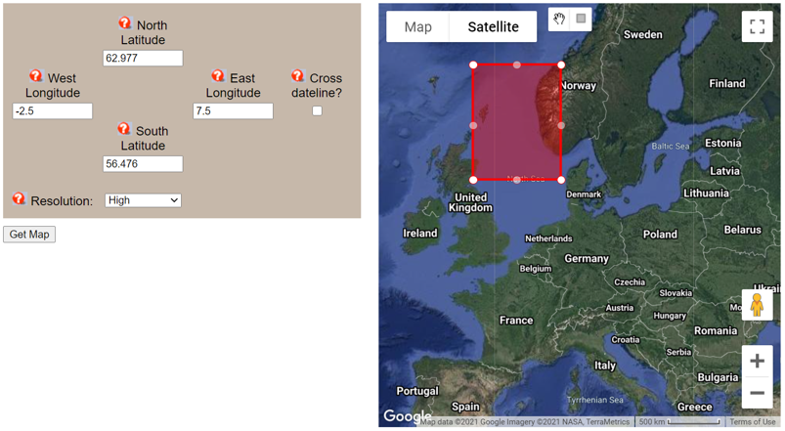

Figure 3.1 Study Area (GOODS 2020)

**3.2 RESEARCH DESIGN**

Due to the time constraints, the research approach adopted for this study is the cross-sectional approach.  Saunders, Phillip, and Thornhill (2012) posit that the cross-sectional approach is the effective method for study that can only be conducted over short period such as few weeks or month as valid in this study. To buttress the former, the data collected for this study is limited to a period of five days. This is so to reduce the prediction inaccuracies of the ocean numerical model (HYCOM) used herein to the barest minimum as it is believed that the accuracy degrades over longer prediction period (Liu et al. 2016). Wang and Cheng (2020) have also pointed out that this approach is a relatively inexpensive method with little ethical implications. According to Wang and Cheng (2020), the cross-sectional approach incorporates both single and multiple data outputs to develop an in-depth study of a given research.

**3.3 DATA TYPE AND SOURCES**

Coastline boundary, movers (ocean current and wind) and spill data are essential parameters for the simulation of an oil spill trajectory using GNOME (Saad and Hamzi 2016; Samuels et al. 2013). These factors where applied in the simulation of the Gullfaks C crude spill trajectory. Map data for coastline boundary was collected using the Global Self-consistent, Hierarchical, High-resolution Shoreline (GSHHS) system developed by NOAA. The boundary under study covers areas between 56.5°N to 63°N and 2.5°W to 7.5° for latitude and longitude respectively and was saved in a GNOME compatible format (.bna).

Data for ocean current was collected from the GNOME Online Oceanographic Data Server (GOODS) with the aid of the Hybrid Coordinate Ocean Model (HYCOM) on the corresponding coordinate boundaries (56.5°N to 63°N and 2.5°W to 7.5°). The data generated was saved using the Network Common form (.nc) format (a GNOME compatible format). Wind data required for the GNOME model as well as other data (sediment load, salinity, and surface temperature, essential for the simulation of the fate and behaviour (using ADIOS) of the Gullfaks C oil slick was gotten from secondary sources such as textbooks, conference materials, journals etc.

**3.3.1 GNOME Model**

In an attempt to reduce the environmental footprint of crude oil on valuable resources, a number of systems have been developed to study and model the processes affecting the distribution and fate of crude when spilled on water (Zelenke et al. 2012). The National Oceanic and Atmospheric Administration’s (NOAA) General NOAA Operational Environment (GNOME) (Beegle-Krause 2001; Marta-Almeida et al. 2013; Zelenke et al. 2012) is an interactive Eulerian/Langrangian spill modelling system designed to rapidly model oil trajectory on water. The GNOME software operates based on a two-dimensional (2D) approach and is written in C++ programming language (Beegle-Krause 2001; Eke and Anifowose 2017; Korsah and Anifowose 2014). Model settings are available at Appendices 4.1 and 4.2.

Input parameters in the GNOME environment includes maps, type of spilled crude, basin bathymetry, location data, meteorological as well as other oceanographic data (Zelenke et al. 2012). According to Beegle-Krause (2001), output from the GNOME model includes movies, graphics, and a number of data files applicable to NOAA emergency response operations or Geographic Information Systems (GIS). The GNOME model displays output in the form of splots that shows the Best Guess Solution (BGS) and Minimum Regret Solution (MRS) (Beegle-Krause 2001; Marta-Almeida et al. 2013; Xu et al. 2013). According to Beegle-Krause (2001) the Best Guess Solution was created with the assumption that wind and current input data are free of error while Marta-Almeida et al. (2013) stated that the Minimum Regret Solution accounts for uncertainty in wind and current input data by increasing the variations in the splot patterns.

NOAA (2002) provided some detailed insight into the GNOME modelling environment. The Eulerian/Langrangian model, with the aid of shoreline maps aids in the modelling of vertically inclined isolated systems covering either hemispheres and also all areas falling under the eastern or western longitudinal lines. Varying resolutions for shoreline map boundaries are available at <http://gnome.orr.noaa.gov/goods> with the aid of the Global Self-consistent, Hierarchical, High-resolution Shoreline (GSHHS) system developed by NOAA. GNOME consists of a limited command-line which allows batch runs to be driven by a text command file. The model consists of two user modes designed for a new user (standard mode) and more sophisticated users (diagnostic mode). An advantage of the Diagnostic mode over the standard mode is that the diagnostic mode provides the user a greater level of control over input parameters. The diagnostic mode however is more useful when the user demonstrates an in-depth knowledge of the modelled region.

Wang et al (2008) posits that the movement of oil slick is controlled by the turbulent diffusion and advection while Zelenke et al. (2012) provides the advection-diffusion equation applied in the GNOME modelling environment (see Equation 3.1-3.3) and has been computed with a forward Euler scheme to attain u and v velocity components representing (east-west) and (north-south) respectively. Compared to the Eulerian formulation, which is effective in dealing with fluid deformations, the Lagrangian formulation provides more accuracy for solid deformation (Souli and Benson 2010) hence Eulerian methods may prove abortive in resolving dispersion for physical numeric conditions (Eke and Anifowose 2017; Guo and Wang 2009). Zelenke et al. (2012) explained that the Lagrangian Elements employed in GNOME constitutes of coordinates which aids in the velocity tracking of the elements and further indicates the encroachment of the splot on land. Fernandes, Neves, and Viesgas (2013) in agreement with Zelenke et al. (2012) suggested the Inability of the GNOME model to simulate vertical displacements (see Equation 3.3).

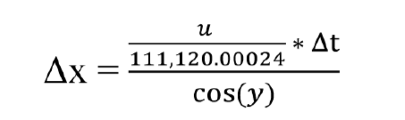 (Equation 3.1)

(Zelenke et al. 2012)

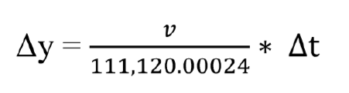 (Equation 3.2)

(Zelenke et al. 2012)

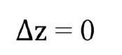 (Equation 3.3)

(Zelenke et al. 2012)

Where,

∆z = vertical displacement

∆t = time elapsed in time steps i

y = latitude (in radians)

∆x = longitudinal displacement

∆y = latitudinal displacement

111,120.00024 = meters per latitudinal degree (where 1 latitude = 1 nautical mile)

In comparison with other modelling environments the GNOME model reportedly produces detailed and accurate analysis despite lacking in three-dimension (3D) capabilities (Duran et al. 2018; Elizaryev et al. 2018; Fernandes, Neves and Viesgas 2013; Marta-Almeida et al. 2013; Nelson and Grubesic 2018)

**3.3.2 HYCOM**

Wave height, wind, current velocity, bathymetry, temperature, salinity, and direction of movers (wind and current) are important input factors essential to run a hydrodynamic simulation (Carafa et al. 2006). The Hybrid Coordinate Ocean Model (HYCOM) is a primitive hydrodynamic model which was developed to correct the flaws of the Miami Isopycnic Ocean Model (MICOM) (Bleck 2002; Carafa et al. 2006; Halliwell 2004). A significant goal in the development of the HYCOM model was to offer the capability of choosing from different vertical mixing schemes (see table 3.1) for the ocean surface mixing layer (Wallcraft et al. 2003). Halliwell (2004) presented a number of limitations faced by the MICOM model such as an inadequate vertical resolution in weakly stratified regions, sub-optimum performance in shallow seas and coastal areas with volatile topographic changes, and provision of smaller reference densities in relation resulting in the inclusion of only slab mixed layer simulations. The HYCOM hydrodynamic model (see Appendix 5) was developed chiefly to overcome these limitations by the inclusion of vertical coordinate types in required regions for optimum performance (Carafa et al. 2006). This implies an improvement in the modelling of turbulence closures (Schiller and Kourafalou 2010). In line with Metzger et al. (2014), the HYCOM model used in this study offers a three-dimension (3D) simulation of ocean temperature, current structure, salinity, and other meso-scale features such as eddies and fronts.

This study employed the use of HYCOM as the hydrodynamic tool to simulate ocean current parameters at play for the Gullfaks C platform area and further incorporated in the GNOME software for analysis. HYCOM offers a Naval Research Laboratory Coupled Ocean Data Assimilation (NCODA) + a 1/12 degree global hindcast analysis indicating that it lies on a 1/12 global degree grid alongside 32 vertical hybrid coordinates. with (Metzger et al. 2014).

Table 3.1: Vertical Mixing Options used in HYCOM (Halliwell 2004)

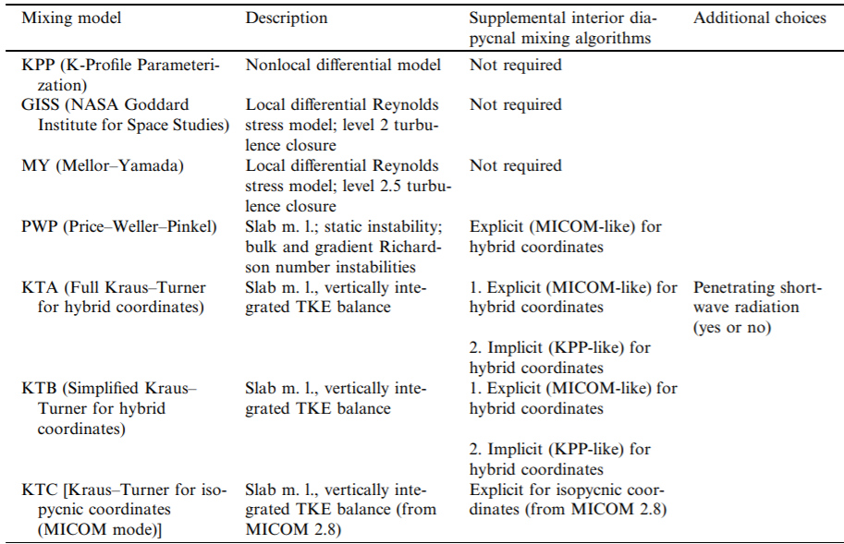

**3.3.3 ADIOS 2**

After an oil spill, the slick will undergo a number of physical and chemical processes collectively referred to as weathering (Fingas 2011; Tarr et al. 2016). These processes generally include evaporation, spreading, photo-oxidation, emulsification, dissolution, dispersion, sedimentation, and biodegradation (Ranieri et al. 2013) and are illustrated in Figure 1.

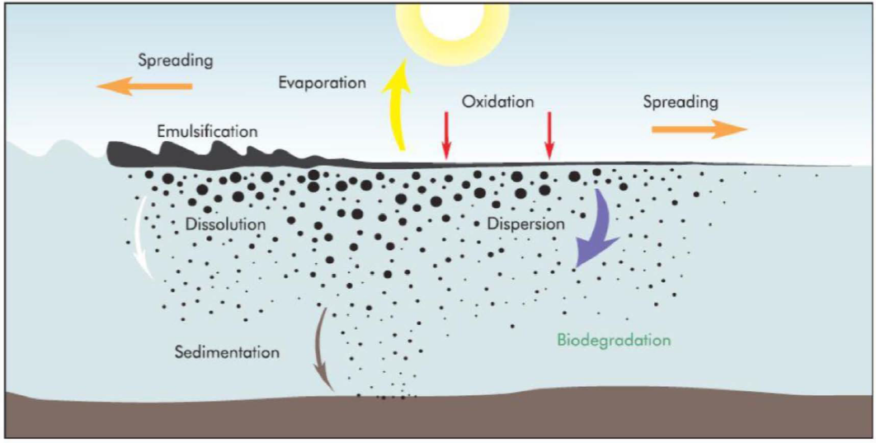

Figure 3.2 : Physical and chemical changes following oil spill (Ranieri et al. 2013)

The nature and impact of the above weathering processes as illustrated in Figure 1 above on the spilled oil can be predicted using an oil weathering model. The Automated Data Inquiry for Oil Spills (ADIOS) is an oil weathering tool developed by NOAA to forecast the different physical and chemical changes of various oil types when spilled in a marine environment (NOAA 2019) (see Appendix 7.1 and 7.2). ADIOS 2 is an upgraded version of the ADIOS 1, developed to provide a more detailed simulation of fate processes as they affect an oil slick (Lehr et al. 2002) as well as account for the shortcomings of the pre-existing ADIOS 1 in terms of performance and data management (Godoy et al. 2020).

Included in the ADIOS 2 database are estimates of the physical and chemical properties of crude oil and its products (over a thousand variations) which is then utilized alongside mathematical equations to predict changes evident in those properties (NOAA 2019). The properties include the viscosity, density, and water content of crude oil or any of its fractions (NOAA 2019). The ADIOS program includes in-built algorithms that accounts for possible clean-up options such as dispersion, in-situ burning, sedimentation, skimming, etc. A limitation of the ADIOS 2 model is that it makes predictions for a maximum of five (5) days and thus undermine the effect of processes such as photo-oxidation and biodegradation which may persist for a longer duration (Berry, Dabrowski, and Lyons 2012; Eke and Anifowose 2017; NOAA 2019). This could increase uncertainties during response operations.

The ADIOS 2 software was developed with specific object-oriented protocols (Lehr et al. 2002). The weathering algorithms contained in the computational engine was is isolated from the platform-dependent user interface and the data base. This is represented on the model platform diagram as illustrated in Fig 3.3. The user supplies environmental and spill data parameters (see table 2) which are further converted to standard units and stored on an electronic black board and consequently applied to the numerical algorithms.

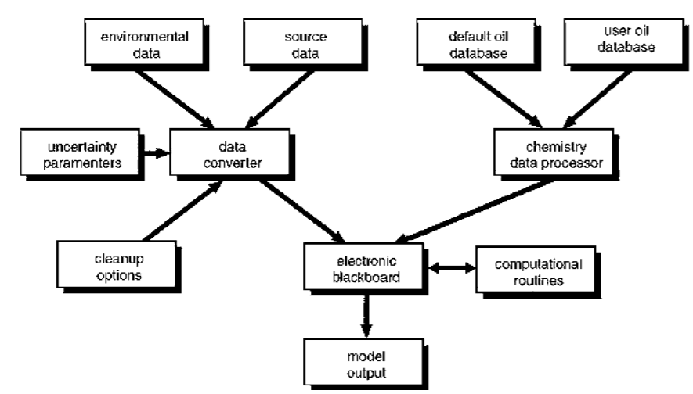

Fig 3.3: Component diagram for ADIOS 2 Model (Lehr et al. 2002)

Table 3.2: Environmental and Spill Input parameters (Lehr et al. 2002). Input Parameters followed by (opt) are optional

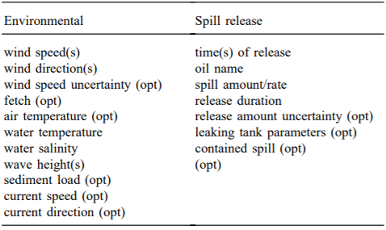

**3.4 TRAJECTORY AND FATE MODELIING PROCEDURE**

The data obtained for the determination of the spill behaviour of the prospective spill at the Gullfaks C platform was analysed with the GNOME (General NOAA Modelling Environment) modelling environment for trajectory simulation and the ADIOS 2 (Automated Data for Inquiry of Oil Spills) software as fate simulation tool.

**3.4.1 Oil Spill Trajectory Simulation**

The GNOME model (version 1.3.11) was set and operated in diagnostic mode. Running the model on diagnostic mode is expedient as it gives a better representation of real-time data, puts into consideration6 all possible modelling parameters, and reduces the level of uncertainties using the minimum regret option. (Eke and Anifowose 2017; Marta-Almeida et al. 2013; NOAA 2002; Xu et al. 2013).

The Gullfaks field map was obtained using NOAA’s Global Self-consistent, Hierarchical, High resolution Shoreline (GSHHS) system from the GOODS website by using the rectangular selector tool to crop the study area. The vector map of the Gullfaks field obtained from the GSHHS was then loaded into the GNOME software. Wesley and Smith (1996) stated that the GSHHG is likely to have reduced internal inconsistencies such as crossing segments, and erratic points given the extensive processing undergone by the software.

To increase the model (GNOME) accuracy, the computational time step in the model settings was set to 0.25 hours (Eke and Anifowose 2017; Korsah and Anifowose 2014; Zelenke et al. 2012) and the minimum regret option was activated.

Current and wind are important factors affecting spill transportation in marine environments (Zelenke et al. 2012) and are therefore relevant processes to simulate on the GNOME modelling environment (NOAA 2002). Current is the dominant factor affecting the redistribution of spilled oil at sea (Carracedo et al. 2006; Deng et al. 2013). The required ocean current data were collected from the GOODS site using the HYCOM hydrodynamic model (Eke and Anifowose 2017) after inserting the required field coordinates (latitude 56.5°N-63°N and longitudinal boundary 2.5°W-7.5°E) (GOODS 2020). The data was then loaded into the GNOME software as movers which are generally wind, diffusion and current (Eke and Anifowose 2017). The along current uncertainty and cross current uncertainty were set at 50% and 25% respectively. The Along Current Uncertainty corresponds to uncertainties in the backward (α < 0) and forward (α > 0) directions while the Cross Current Uncertainty is represented by (β <0) and (β < 0) for left and right directions respectively (Zelenke et al. 2012). The uncertainty duration was set to five (5) days.

Though current remains the dominant factor affecting the transport of ocean slick (Carracedo et al. 2006), the movement of the oil slick is affected by 3-5% of the total windspeed at an area (Reed, Turner, and Odulo 1994; Ridgway 1972). To this effect, wind data was obtained from experiments of a near surface marine wind profiling survey carried out in the Gullfaks C area by Furevik and Haakenstad (2012). The wind speed obtained from Furevik and Haakenstad (2012) was 11.4m/s and direction as NNE (North-North East) and was converted to knots (22knots). The average wave height in the Gullfaks C area is 2.5 meters (m) (Meteorologisk Institute 1997). Diffusion was set to GNOME default setting at 100,00cm2 s- 1 to account for the horizontal eddy diffusivity in water (Zelenke et al. 2012) due to the ignorance coefficient. The type source was selected as “point/line source”. This suggest that the oil leak was generated from a single point (NOAA 2019). To determine the display output and map window, the “number of splots” was set at 1000 (Eke and Anifowose 2017; Korsah and Anifowose 2014). Lehr et al. (2002) posits that pollutant type selection is important in ADIOS2 and GNOME simulations. The medium crude option was selected for pollutant type as opposed to Equinor (2019) who described the Gullfaks blend oil as light crude. More so, Zelenke et al. (2012) posits that the “non weathering” option should be used in real life conditions. This may be related to the reliability and performance of the model as regards to type selection. on selection, the “non weathering” option failed to account for evaporation. The oil type selection was then set at medium crude given an API of 29.3. The amount of released oil was set at 39000 barrels per day (Equinor 2019) for a spill duration of 5 days amounting to a total spill of 195,000 barrels of oil. The 5-day spill duration was selected to aid uniformity between the GNOME and ADIOS 2 model as the ADIOS 2 model can precisely simulate spill within a 5-day period (Marta-Almeida et al. 2013).

The study ran a spill scenario using wind, current and diffusion variables for the determination Gullfaks C’s likely trajectory on spillage. Vertical displacement of oil slick cannot be modelled by the GNOME software (see Equation 3…), thus posing as a limitation of the software. Nevertheless, the GNOME model is efficient, robust, and fully relocatable (Eke and Anifowose 2017; Marta-Almeida et al. 2013) and free (Xu et al. 2013). More so, in comparison to other models, the GNOME model requires fewer environmental and spill input parameters (NOAA 2019) thereby making it suited for this study.

**3.4.2 Oil Weathering:**

The weathering character of the Gullfaks C crude (see Appendix 6) was determined with the aid of the ADIOS 2 modelling tool. The model simulated a continuous spill of 195,000 barrels of oil for summer and winter months. For oil type, the Gullfaks crude of API 29.3 was selected from the ADIOS 2 library. The Pour point, Flash point and Aromatics composition were 32°C, -8°C and 35% respectively for both summer and winter months. The water temperature for winter and summer months were set at 46°F and 64°F respectively (Morris et al. 2018). Due to temperature difference in winter and summer seasons, there density, viscosity, and adhesion readings from the ADIOS 2 library were uneven. The variation in density and viscosity of a fluid due to temperature is related to a rise in kinetic energy of the fluid (Ahammed, Asirvatham, and Wongwises 2015). A constant Wind speed, wind direction and wind height were set to 22knots, 315° and 2.5 meters respectively (Furevik and Haakenstad 2012; Meteorologisk Institute 1997). The wind speed in summer months was set at 15knots (Furevik and Haakenstad 2012). The salinity for the study area was obtained from well log data samples (Gran, Bjørlykke, and Aagaard 1992) and set at 35 ppt while the sediment load reading was obtained from the ADIOS 2 library at 5g/m3. Surface current and direction was obtained from (Vinedenes et al. 2018) and set at 0.2m/s (0.4knots). The time of release was set at 25th November at 12:00 hrs and the amount spilled, and duration were set at 195,000 barrels and 5 days, respectively. Table 3.2 summarises the environmental data inputted in the ADIOS 2 model.

Table 3.3 Environmental Input Data for ADIOS 2 Source

|  |  |  |
| --- | --- | --- |
| Environmental Parameter | Summer | Winter |
| Average Wind Speed | 15 knots | 22 knots |
| Wind Direction | North Westerly | North Westerly |
| Wave Height | 2.5 m | 2.5 m |
| Average Sea Surface Temperature | 46°F | 64°F |
| Average Salinity | 35 PSU | 35 PSU |
| Water Sedimentation | 5g/m3 | 5g/m3 |
| Surface Current Speed | 0.2m/s (0.39knots) | 0.2m/s (0.39knots) |
| Current Direction | South East | South East |

A limitation to the ADIOS 2 model may be due to its abilty to let users create different custom oils. Contrastly the limitation faced by the GNOME model is eliminated by the incorporation of the ADIOS 2 model during fate simulation (Beegle-Krause 2001; Eke and Anifowose 2017; Zelenke et al. 2012) and its zero cost requirements.

**3.5 CHAPTER SUMMARY**

The cross-sectional approach was employed in this study due to time constraints which was a period of 5 days. The study gives an operational overview of the GNOME, ADIOS 2 and HYCOM models. Ocean current data was obtained from the GOODS site with the aid of the HYCOM model. Wind data and other essential parameters (sediment load, water temperature salinity etc.) relevant for fate modelling (using ADIOS) were obtained from textbooks, journals , and conference materials etc. limitations faced by GNOME model in its inability to model vertical displacement of oil is compensated by robustness and efficiency of the model. the ADIOS 2 limitation to let users create different custom oil is compensated for by the incorporation of the ADIOS2 model in weathering.

**CHAPTER FOUR**

**4.0 DISCUSSION AND ANALYSIS**

**4.1 OIL SPILL TRAJECTORY ANALYSIS**

The oil spill trajectory analysis of the Gullfaks platform C area was carried out using the General NOAA Modelling Environment (GNOME) for a duration of 5 days (November 25th – November 30th). The employed wind speed and direction for the period was 22knots and North Westerly respectively (Furevik and Haakenstad 2012). The sea current velocity as obtained from HYCOM (see Figure 4.2) was loaded in the GNOME model. The model accounted for 99.8% (194,591 barrels) of the total production rate (195,000 barrels) at the Gullfaks C platform, leaving 0.2% (390 barrels) of the oil unaccounted for. This may be due to model settings accounting for residual oil following spill.

The results obtained from the GNOME analysis (see figure 4.1) suggests that 68.4% (133,029 barrels) of the total spill was floating at the end of the 5-day simulation period, while the remaining 31.64% (61,561 barrels) was evaporated. The amount of oil afloat is dependent on the density of the oil (API) and salinity of the water (NOAA 2020). The results agree with NOAA (2020) which suggests that medium-type crude oil will float on water. The amount of evaporated oil may also be influenced by the wind speed as well as temperature variations (Tasaki and Ogawa 1999; Wang 2014). Similarly, Fingas (1999) attributed the rate of evaporation to increasing wind speed. The simulation by the GNOME model shows that no oil was spilled outside the map boundary for the 5-day period. This implies that the dominant processes of oil transport operated entirely within the selected coordinates (NOAA 2019). The Best Guess Solution also indicated that no oil was beached throughout the 5-day period. This implies the absence of onshore winds as suggested by Khadka (2020) suggesting the influence of onshore winds to a beaching outcome. The zero percent (0%) beaching outcome may also be related to the oil type as heavier oils tend persist and thus beach with time (Fingas 2011).

Results from the GNOME model records the point of spill to be within latitude 61°13.17’N and 2°15.57’E and stretches vertically for about 145km to 59°39.21N, 3°31.24’E in the five-day period. The spill had a horizontal orientation reaching 16km according to Best Guess Solution (BGS). At the end of the oil spill duration the distance from the oil slick as represented by the splots from shoreline (Bergen area) was 72km (BGS) at 59°59.53’N and 3°45.20’E.

The location of the spill scenario in the open North Sea suggests a major contribution of wind in the determination of the velocity of the oil slick. Overstreet and Galt (1995) stated that spills at sea, unlike rivers owe its transport to advection forces (wind and current). This is represented in Figure 4.3 and Figure 4.4. The foregoing premise suggest that wind influences oil slick motion thereby having a slightly higher velocity than the surface velocity given the required wind direction (Overstreet and Galt 1995; Yapa and Tao Shen 1994). Comparing Figure 4.4 and 4.5 indicates the extent of transport by wind which was measured at 119km. The area covered by wind (119km) exceeds over 2/3 of the total extent of transport by the slick (145km) which further implies that wind was the dominant advective process in the Gullfaks C spill. The Clair field, proximal to the Gullfaks C reports similar dominance of wind transport over ocean current in slick transport (Eke and Anifowose 2017).

**Contrary to Simecek-Beatty (2011) who posits that oil slick will move at constant speed with current velocity, the analysed spill from the GNOME analysis will be influenced by 3% of the total wind speed (22knots). The foregoing premise is supported by Fingas (2011) and Wang et al. (2008) who explained that an oil slick will not be transported at 100% current velocity given that the wind speed exceeds 5knots (which is the case in this scenario) and propagated in the same direction as the ocean current (see Figure 2.3).** Althou gh, Overstreet and Galt (1995) suggest that the total contribution of wind to oil slick transport ranges from 0.7% to 1.4%. In contrast, this value may range from 1% to 6% (Simecek-Beatty 2011; Yapa and Tao Shen 1994). Difference in results may be due to differential methodologies used.

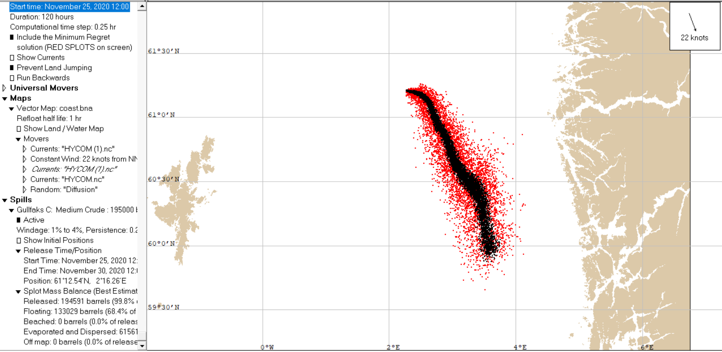

Figure 4.1 : GNOME analysis of Gullfaks Platform C oil Spill Trajectory

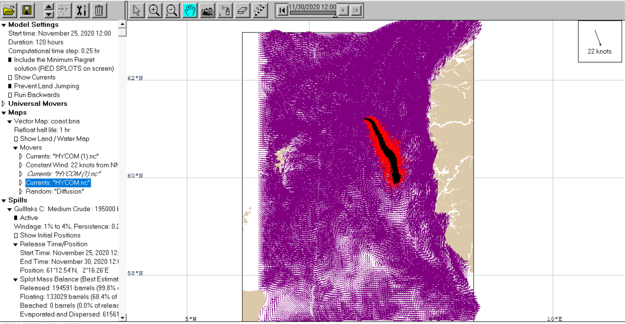

Figure 4.2 Ocean Current Obtained from HYCOM

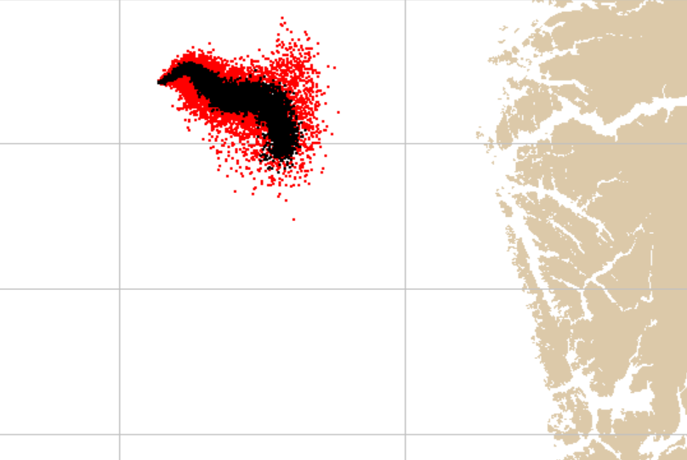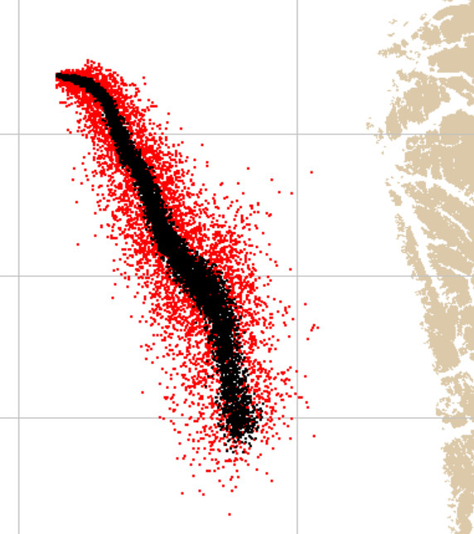

Figure 4.3: GNOME Model without wind Figure 4.4: GNOME Model with wind

Alongside wind and current, turbulent diffusion (see Figure 4.4 and 4.5) plays an essential role in oil movement. From the GNOME analysis, it was observed that the slick width of 16km was reduced to 6.8km (at the widest point) when the diffusion tab was set inactive. Therefore, diffusion accounted for slick transport of about 9.2km (16km minus 6.8km) horizontally throughout the extent of the spilled area. An implication of this finding is thus that the direction of diffusion is perpendicular to the direction of the dominant transport factor (wind). The cause of diffusion may be as a result of an in-flow of dense water from the Nordic sea into the North Sea (Eke and Anifowose 2017; Mauritzen et al. 2005).

Langmuir streaks tends to form when wind speed is 50 times greater than (>) the current velocity (Smith and Thorpe 1999). From the GNOME analysis, the wind speed (22 knots) is over 55 times greater than the current speed (0.4 knots). This supports the above requirement for the formation of Langmuir streaks and thus may form. Likewise, from the analysis, Windrows may form as the wind speed exceeds 6 knots (Smith and Thorpe 1999).

**4.1.1 Minimum Regret Analysis**

As evident by the red splots (see Figure 4.7) the Minimum Regret Solution (MRS) analysis is essential in improving the accuracy of GNOME simulations (see Appendix 3.2) thereby reducing uncertainties that may rise due to variations in environmental conditions (Eke and Anifowose 2017; Spaulding 2017). Results from the MRS analysis accounts for a wider coverage of the spilled area (Eke and Anifowose 2017) as illustrated in Figure 4.8. This phenomenon may be due to the variations in uncertainty parameters used by the GNOME environment (Zelenke et al. 2012). On activation of the minimum regret option, the distance from the spill (after 5-day spill duration) to the shoreline reduced from 72km (BGS) to 29km (MRS). Furthermore, the longitudinal extent (length) of the spill increased from 145km (BGS) to 175km (MRS) while the width of the affected region increased from 16km (BGS) to 52km (MRS). The difference between the Best Guess Solution (BGS) and Minimum Regret Solution (MRS) is evident in Figures 4.7 and 4.8.

Despite the activation of the minimum regret option to the study area, the analysis did not reveal any evidence of beaching. This could be due to the absence of onshore winds during the simulation period (Bejarano and Michel 2016). This may be the case (zero oil beaching) even for a longer spill duration given the slick distance from shore and direction of oil trajectory. To this effect, no shoreline protection is recommended. However, the use of chemical dispersants to aid natural dispersion is advised to avert its potential footprint on resources (Brandvik 1988).

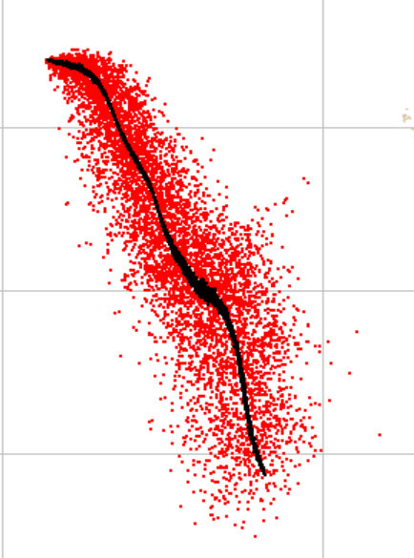 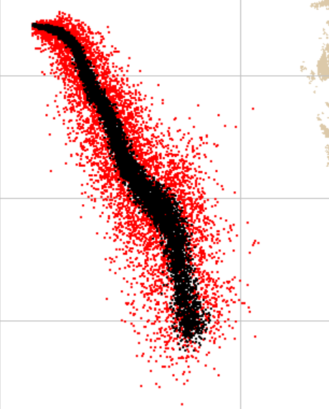

Figure 4.5: GNOME Analysis without Turbulent diffusion Figure 4.6: GNOME Analysis with Turbulent diffusion

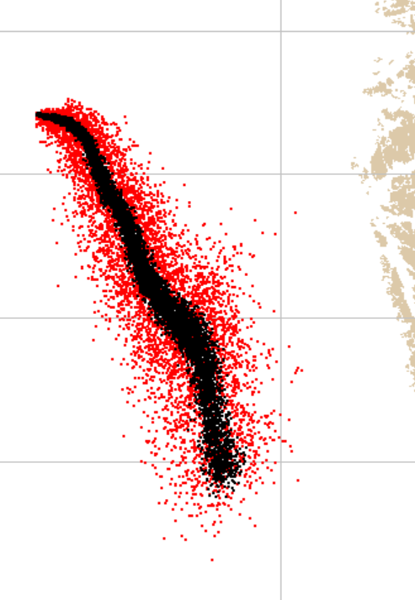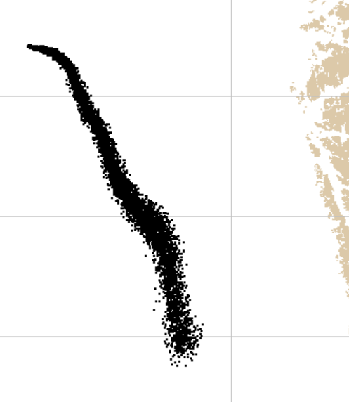

Figure 4:7 : Gnome splots with minimum regret solution Figure 4.8 : GNOME splots without minimum regret solution

**4.2 WEATHERING Analysis**

**4.2.1 Evaporation**

The Gullfaks platform C spill simulation using ADIOS 2 indicated that about 27.5% (summer) and 24% (winter) (see Figures 4.9 and 4.10) of the released oil will be lost due to evaporation. This falls in line with a study by Brandvik (1988) suggesting that Norwegian spills will generally experience 15-30% loss due to evaporation. The study (Brandvik 1988) also implied that at least 15% of the Norwegian crude will be evaporated in the first 24 hours following the spill. In contrast, it was observed that 17% of the crude was evaporated at winter in the first 24 hours while about 20 % of the spilled oil was evaporated during the winter months. Therefore, both winter and summer simulation by the ADIOS 2 software deviates from the findings by Brandvik (1988). Furthermore, Sebastião and Soares (1995) suggested that oil slick to be lost during evaporation in the first day of spill should range between (20-30%) of total released oil. While the summer months simulations fall in line with the study (Sebastião and Soares 1995), ADIOS 2 simulations for winter seasons falls short of the estimate with an observed 3% deviation.

From the weathering analysis, it was observed that oil loss due to evaporation in the first 2days of spill was about 80% and 92% for winter and summer months, respectively. This supports Fingas (2013) position that evaporation within the first 48 hours of spill will be equal or greater than ( >) 80%. Likewise, the evaporation in the area will be influenced by air boundary layer, composition of the crude as well as its salinity (Fingas 2013; Fingas 2011).

Oil composition and physical properties poses some influence on evaporation (Jordan and Payne 1980). Spilled components of light and medium crude oil type will be evaporated within the first 10 days of spillage by virtue of its C15 proportion (Lee et al. 2015). This implies that all evaporated oil within the 5-day modelling duration was equal or less than C15 in terms of complexity while those remaining afloat are more complex hydrocarbons.

Results from ADIOS 2 and GNOME rates of evaporation shows some similarities as each software simulations of total evaporation loss ranges between 20% to 35%. An average can be arrived for ADIOS 2 (24% at winter) and GNOME (31%) for better and informed response measures. The difference in evaporation rates as suggested may be due to the difference in wind speed (Tasaki and Ogawa 1999) and seasonal temperature variations (Eke and Anifowose 2017).

**4.2.2 Emulsification:**

The type of emulsion formed by an oil-water interaction is determined by the water uptake of the oil (Fingas 2013; Fingas 2011; Lee et al. 2015). Fingas, Fieldhouse, and Mullin (1996) provided the basis for calculations in ADIOS 2 framework for emulsification (see Appendix 2). As observed from the ADIOS 2 software, the model indicates that water intake commenced at around 6 hours and 8 hours for summer and winter periods, respectively (see Figure 4.11 and Figure 4.12). Fingas and Fieldhouse (2003) defined stable emulsions as those containing over 60%-80% of water. Likewise, Lee (2014) has described stable emulsions as an emulsion where the water content persists for over 5 days. Based on these parameters the Gullfaks C emulsion with about 76% and 80% water content for winter and summer periods can be described as a stable emulsion. Based on the formation criteria provided by Fingas and Fieldhouse (2003), the formation of stable emulsions began after 36 hours of spill in both summer and winter seasons. As indicated by the model, stable emulsions (mousse) begin to form after 19% of the spilled oil is evaporated. This implies that the formation of stable emulsions in this study can be related to a decline in the rate of evaporation in summer and winter seasons (Fingas 2011; Sztukowski and Yarranton 2005)

**4.2.3 Viscosity and Density**

The ADIOS 2 analysis of both Viscosity and Density parameters showed similar behavioural patterns within the first 48 hours of spill (see Figure 4.11-4.14). From the ADIOS 2 analysis, the density and viscosity of the crude increases abruptly within the first 24 hours of spill. This could be due to the evaporation of lighter particles with lesser complexities than the Carbon 15 chain (Lee et al. 2015). This also suggests a reduction in the saturation of the hydrocarbons and thus implies the increase in the concentration asphaltenes , sulphur and resins after the first 24 hours of spill (National Academy of Sciences 2015). The increase in viscosity and density of the Gullfaks C crude over time may reduce the rate of spreading as the rate of spreading is inversely proportional to an increase in viscosity and density of crude (ITOPF 2018). Similarly, the density and viscosity curves suggest a drop in the temperature as crude viscosity and density will generally increase with a drop in temperature (ITOPF 2018). Comparing the curves for emulsification, density and viscosity indicates and increasing progression of these parameters. This correlates with a study by Fingas (2013) suggesting that viscosity and density increases with increasing rates of emulsification.

**4.2.4 Dispersion:**

In the first 24 hours of the spill using the ADIOS 2 model, it was observed that about 4.2% and 3.9% of oil had been dispersed in winter and summer periods (see Figure 4.17 and 4.18) respectively. During the 5-day duration of the spill, the model indicated that about 6.5% and 5.8% of oil had been dispersed in winter and summer periods, respectively. Comparing the rate of dispersion with other ADIOS 2 modelled parameters indicates that the rate of dispersion of oil reduces with increasing density, viscosity, and emulsification (Chandrasekar, Sorial, and Weaver 2006; ITOPF 2018). The study also suggest that dispersion was more in the winter than in the summer periods. This suggests that higher temperature holds little significance in the rate of dispersion (Chandrasekar, Sorial, and Weaver 2006). However, Lehr et al. (2002) attributes the difference of dispersion rates in winter and summer seasons to be as a result of breaking waves and turbulence differences. This however implies some uncertainties as the current and wave conditions for both seasons are constant. Another study by Escobar et al. (2016) suggested that temperature plays a role in open sea hydrodynamics (current and wind influence) and thus may have an indirect influence on dispersion.

**4.2.5 Airborne Benzene Concentration**

According to the weathering simulation by ADIOS 2. Airborne benzene concentration on release was about 30ppm for both summer and winter simulations. it was further observed that the concentration of benzene fell below 1ppm in 14 hours. This conforms with a study by Lehr et al. (2002) positing that airborne benzene will evaporate within 15 hours during the summer period. According to EPA (2007), benzene concentrations below 1ppm would be negligible as it poses little threat to organisms. Lehr et al. (2002) posed that a difference in wind speed will result in different benzene concentrations in both seasons. In contrast, there was insignificant difference in the benzene concentrations in both seasons (see Figure 4.19 and 4.20) despite the difference in summer (15knots) and winter wind (22knots) speeds.

**4.2.6 Sedimentation**

From the ADIOS 2 library and data gathered by Equinor (2020) the oil type found in the Gullfaks C area is light-medium crude. Given the specific gravity of water at 1.03 Marcet (1819), only heavy crude will form sediments (ITOPF 2018; Lehr et al. 2002). This implies that the crude in this region will not form significant sedimentation.

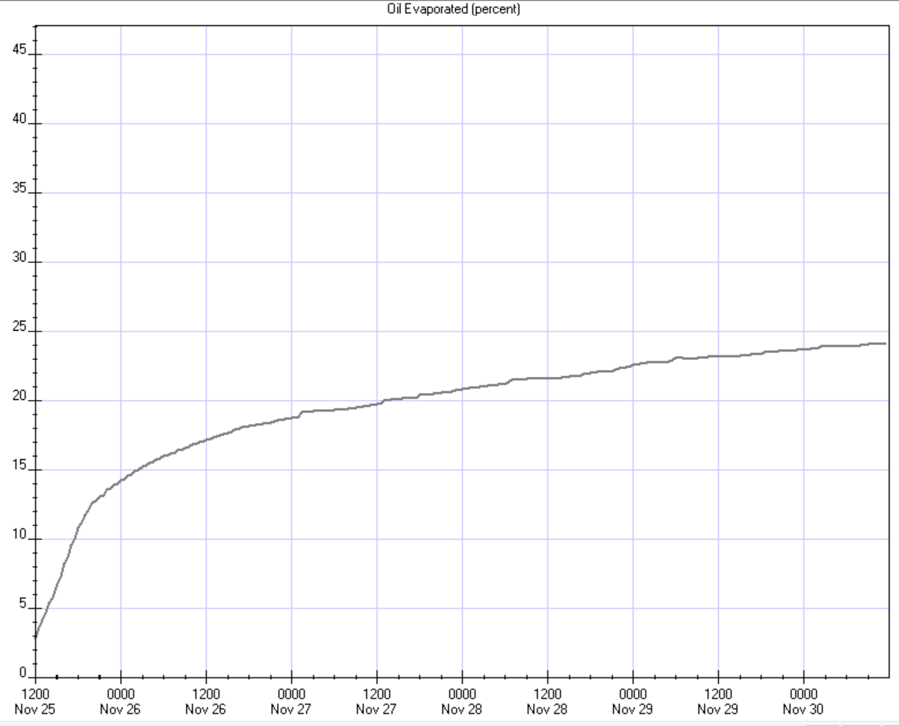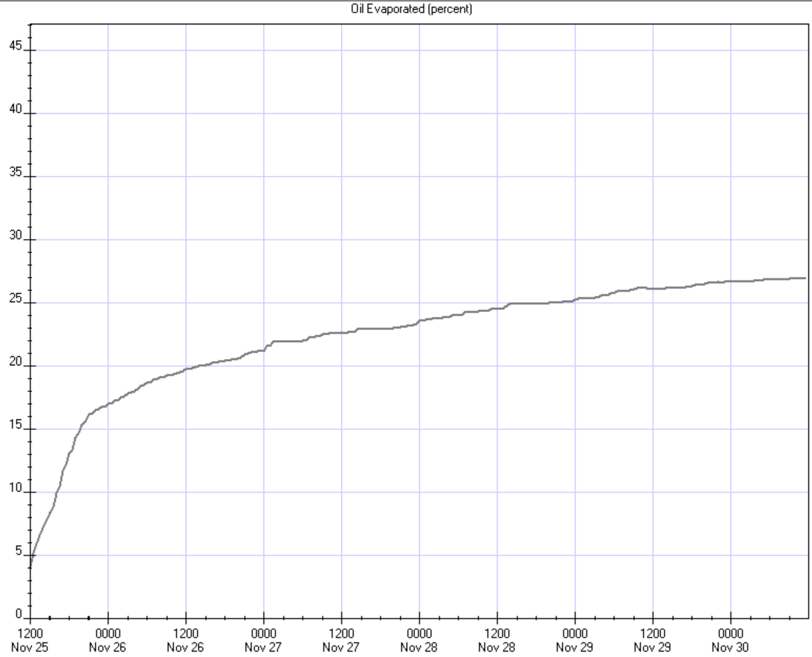

Figure 4.9 : Evaporation during Winter at 46◦F Figure 4.10 : Evaporation during Summer at 64◦F

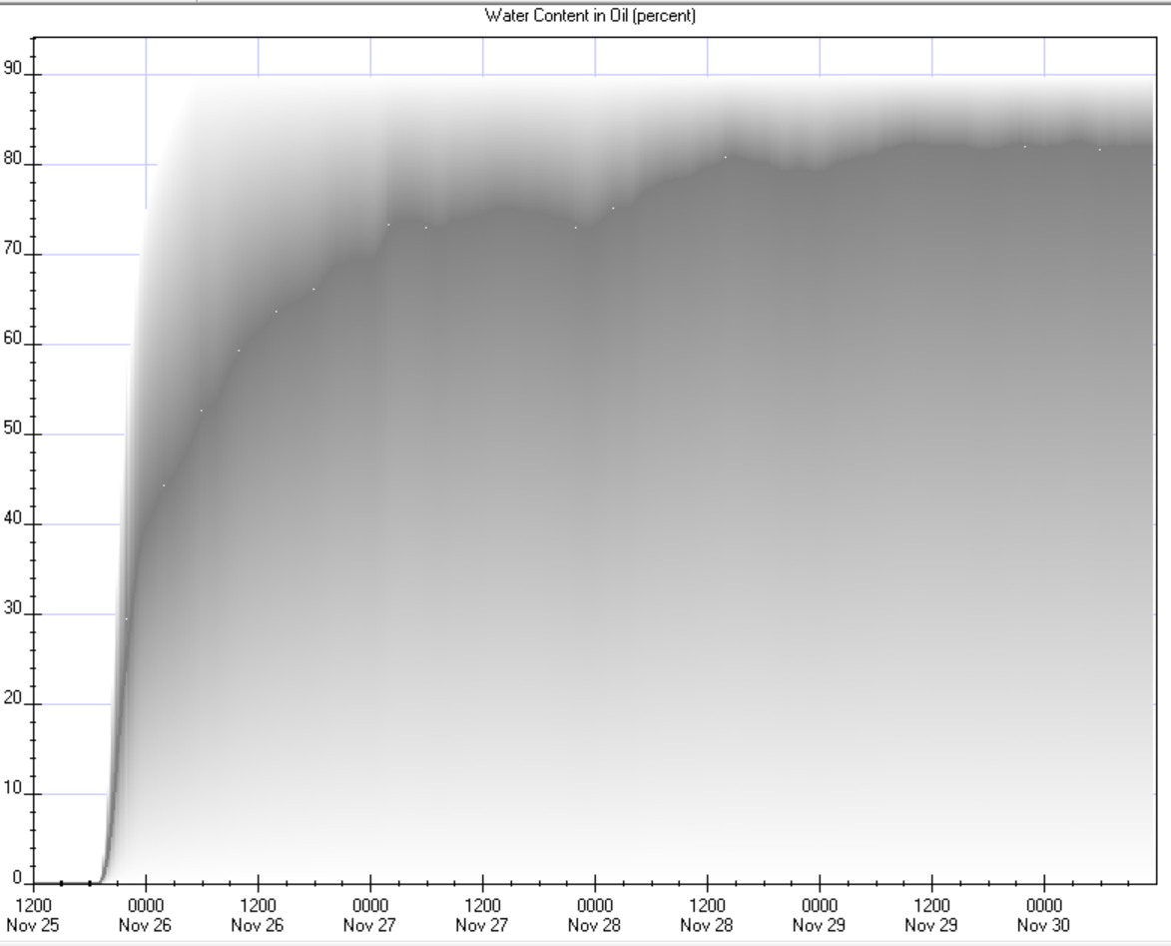 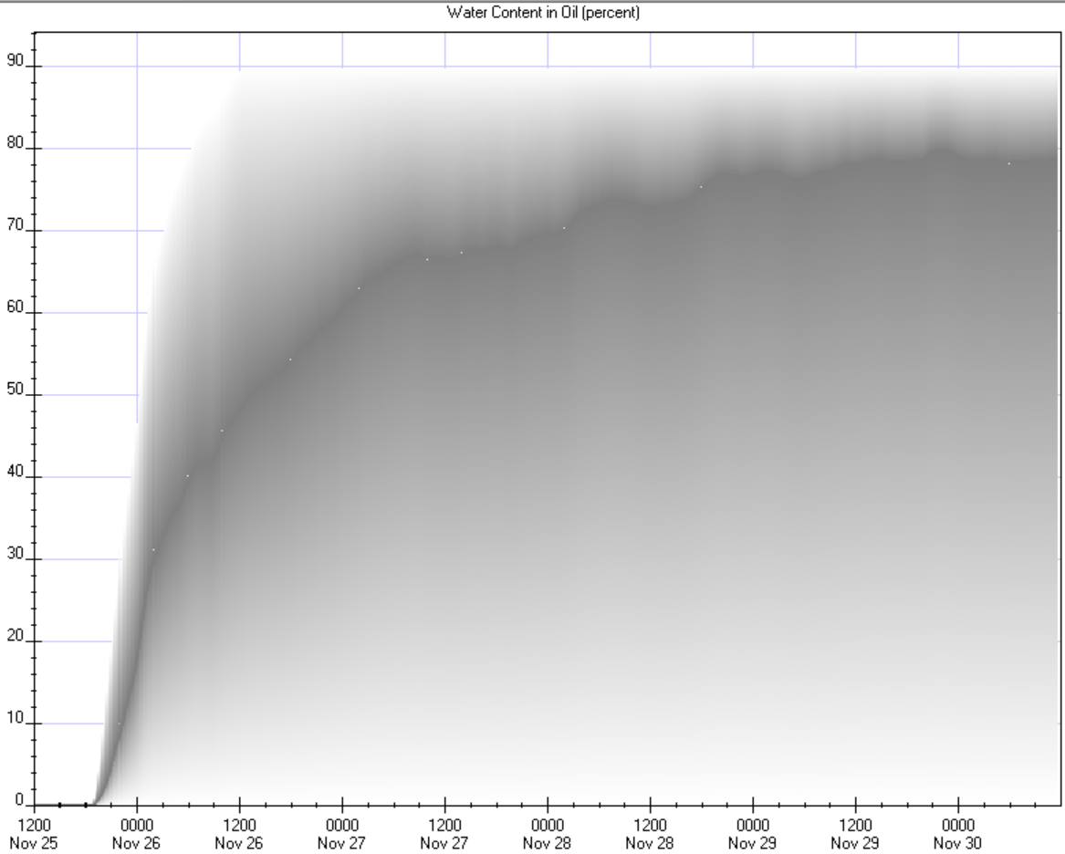

Figure 4.11 : Emulsification during Winter at 46◦ F Figure 4.12 : Emulsification during Summer at 64◦

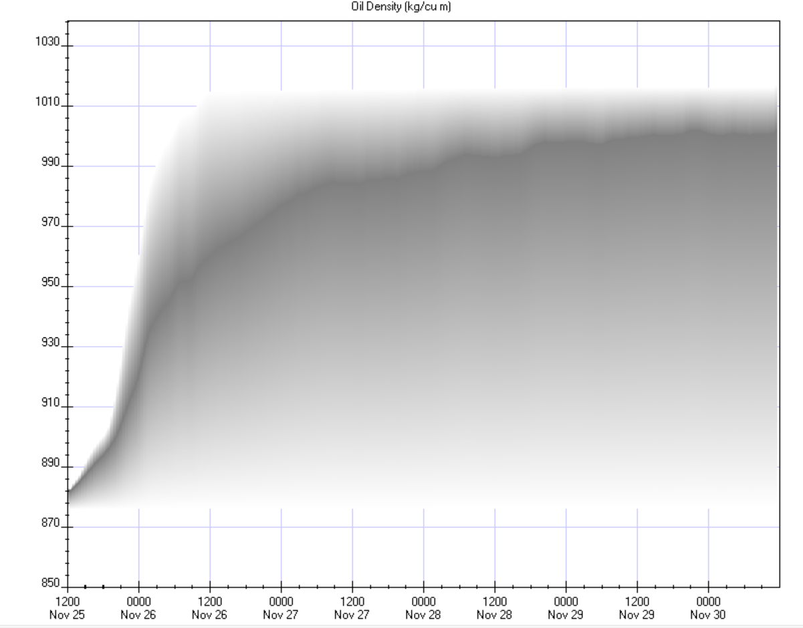 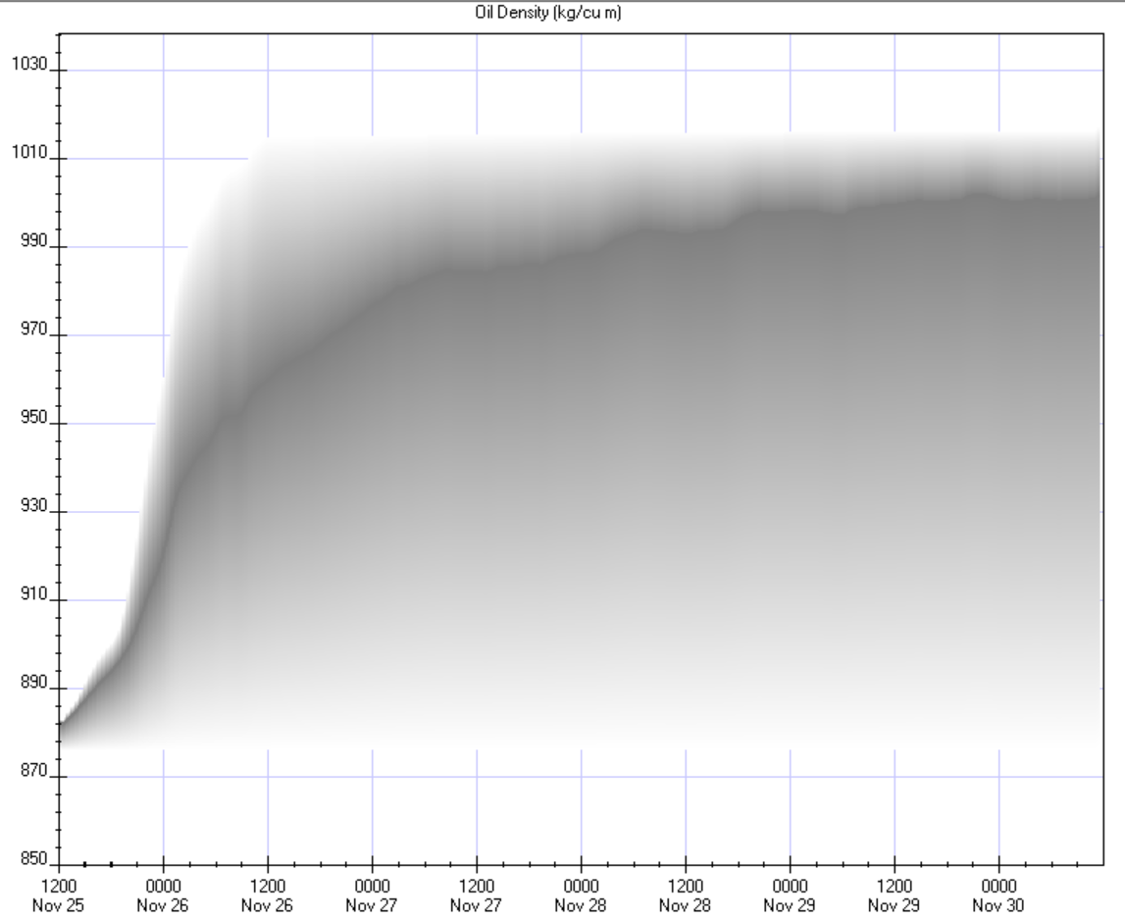

Figure 4.13 : Density during Winter at 46◦ F Figure 4.14 : Density during Winter at 64◦ F

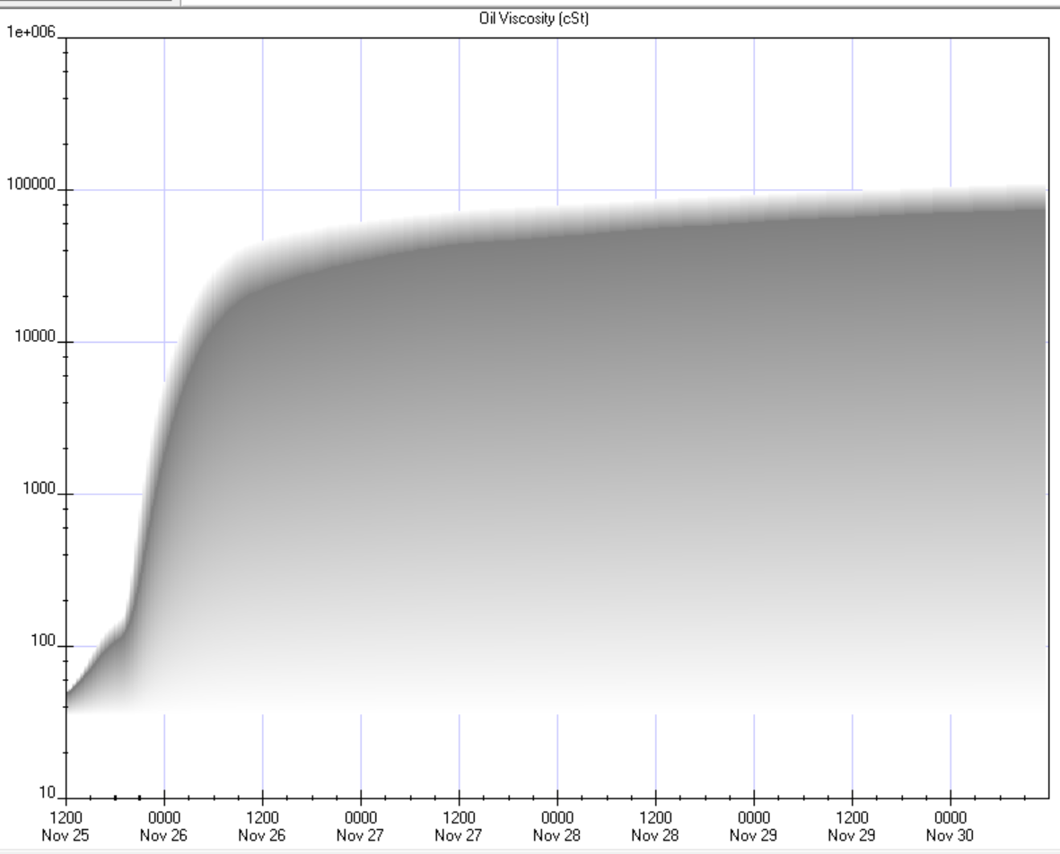 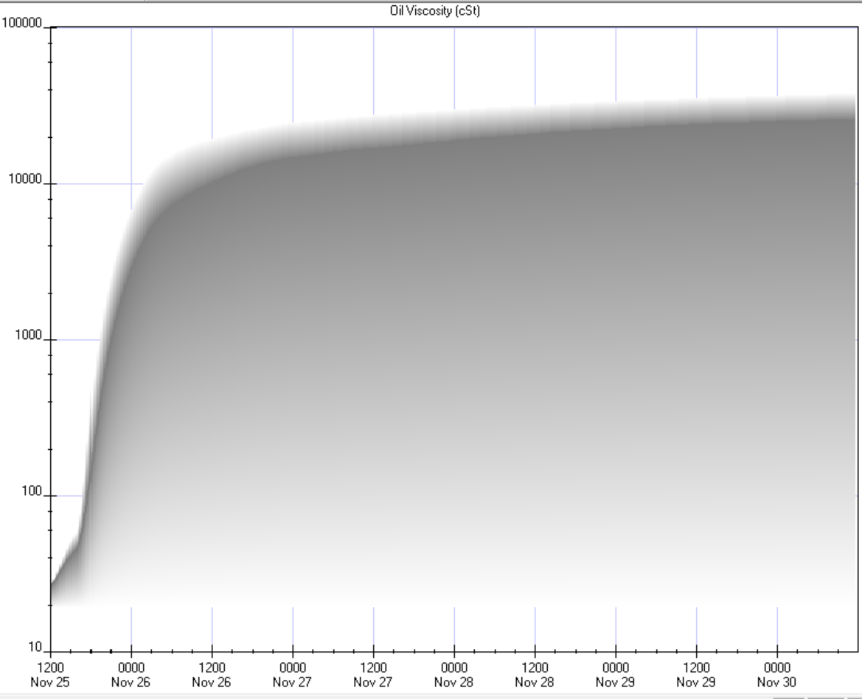

Figure 4.15 : Viscosity during Winter at 46◦ F Figure 4.16 : Viscosity during Winter at 64◦ F

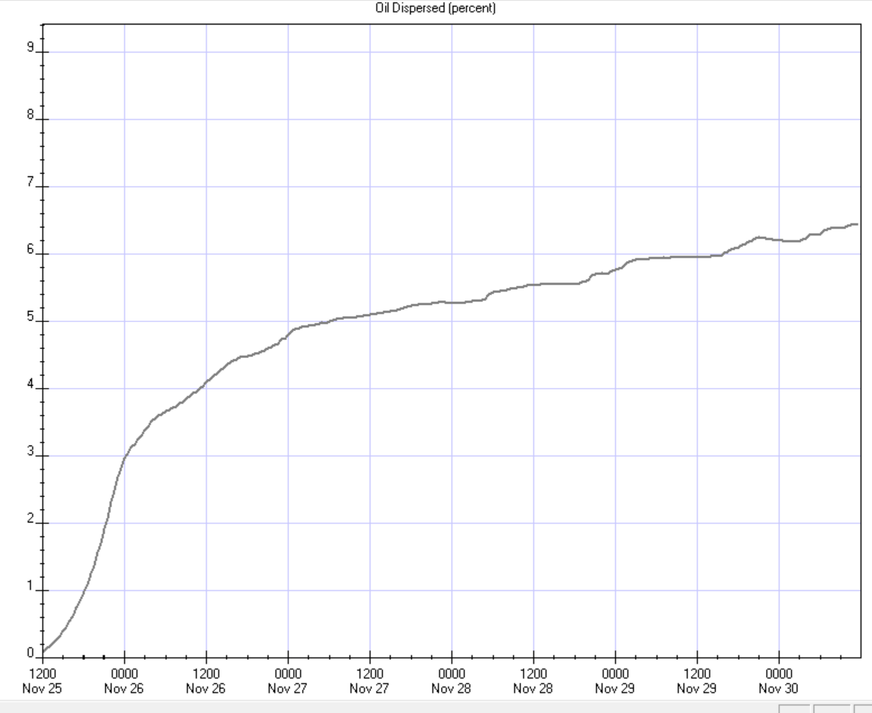 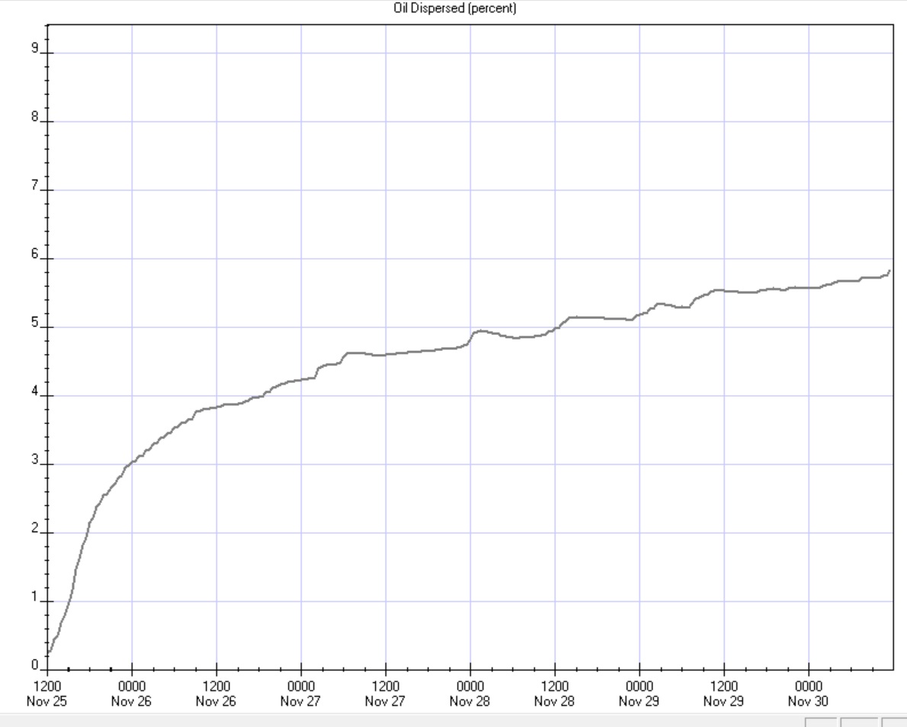

Figure 4.17 : Dispersion during Winter at 46◦ F Figure 4.18 : Dispersion during Summer at 64◦ F

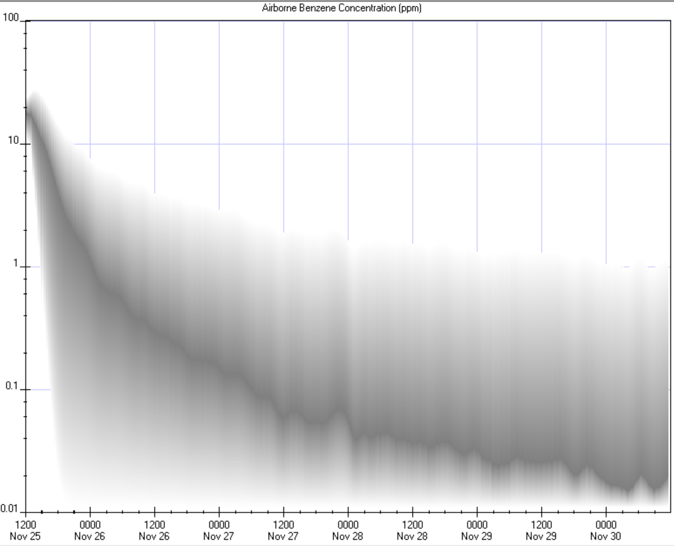 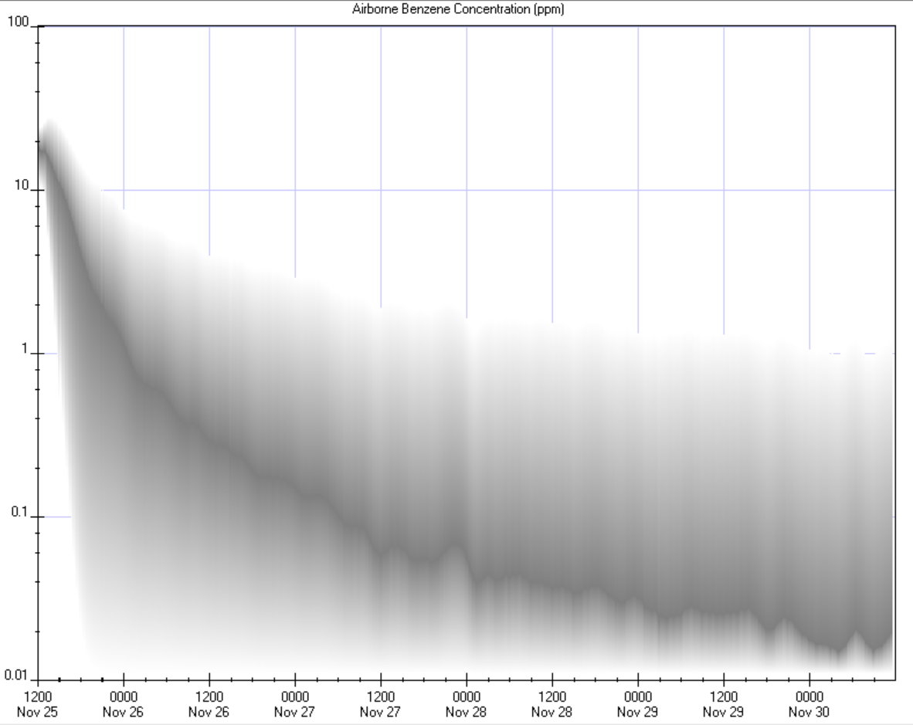

Figure 4.19 :Airborne Benzene during Winter at 46◦ F Figure 4.20 : Airborne Benzene during Summer at 64◦ F

**CHAPTER FIVE**

**5.0 CONCLUSION AND RECOMMENDATION**

**5.1 CONCLUSION**

The GNOME and ADIOS2 models were employed to simulate the trajectory and fate of an oil spill scenario in the GULLFAKS C area. The GNOME model accounted for transport processes such as wind, ocean current and diffusion while the ADIOS2 weathering model accounted for evaporation, emulsification, airborne benzene concentration and dispersion processes. The GNOME model simulated 99.8% of the total spilled oil, failing to account for 0.2% (390 barrels). At the end of the 5-day period, 68.4% (133,029 barrels) of the total spilled oil floated while 31.64% (61,561 barrels) evaporated. Best Guess Solution (BGS) and Minimum Regret Solution (MRS) indicates that no oil beached during the 5-day period. The Spill extended over 145km (BGS) and 175km (MRS) with closest distance from the Bergen shoreline reaching 72km (BGS) and 25km (MRS). The correlation of the GNOME results with literature indicates that the slick will move at 3% of the wind speed (22knots) alongside the influence from current and diffusion. Wind was the dominant force of oil slick transport as oil transport due to wind covered over 119km (BGS). Turbulent diffusion accounted for 9.2km slick motion to an axis perpendicular to the direction of wind propagation. Langmuir streaks may form as the wind speed (22 knots) is over 55 times greater than local current speed (0.4 knots). The formation of Windrows is expected as the wind speed exceeds 6 knots. Minimum regret analysis did not reveal a beaching outcome in the 5-day period nor suggest prospects for future beaching after the model duration.

ADIOS2 simulation indicates oil loss due to evaporation to be 24% at winter and 27.5% during summer. Oil lost due to evaporation after 2 days were about 92% and 80% (for only evaporation loss) for summer and winter months, respectively. Results suggests that temperature variation, wind speed and oil composition may be possible factors affecting differential rates of evaporation in summer and winter seasons. Water intake by oil started at 8hours and 6 hours for winter and summer periods, respectively. The formation of stable emulsions commenced after 36 hours of spill for both seasons and after 19% of oil had evaporated. Results suggests an increase in emulsification rate following a decline in evaporation rate. ADIOS2 analysis indicates a sharp increase in density and viscosity within the first 24 hours of spill. The rate of spreading is expected to reduce following the progressive increase in viscosity and spreading after the first 24 hours. About 3.9% and 4.2% for summer and winter respectively was dispersed in the 5-day model duration. Dispersion rates were indirectly proportional to density and viscosity and directly proportional to increasing temperature. Air borne concentration of benzene fell from a concentration of 30ppm to about 1 ppm in 14 hours.8

**5.2 RECOMMENDATIONS**

* More studies on the fate and trajectory of oil slicks should be carried out in the Norwegian North Sea. Therefore, efforts should be made by stakeholders in the Norwegian Petroleum Directorate and other relevant bodies towards the collection and provision of real time environmental and spill data.
* New and existing laws and policies regarding the regulation of exploration and exploitation of oil should be enacted and strengthened to ensure strict compliance by oil companies.
* Training and enlightenment of personnel is encouraged to ensure that spill accidents are managed and prevented.
* Furthermore, some of the spilled oil may sink due to increase in oil density overtime, therefore, an incorporation of a 3D model is advised so as to model spills within the water column as they may upwell later on to the surface.
* the use of spill models that simulates a longer spill duration period is encouraged for enhanced accuracy and predictions.

**REFERENCES**

Aamo, O.M., Reed, M., and Lewis, A. (1997) “Regional Contingency Planning Using the OSCAR Oil Spill Contingency and Response Model”. *www.Osti.Gov* [online] 1. available from <https://www.osti.gov/etdeweb/biblio/536034> [19 November 2020]

Afenyo, M., Khan, F., Veitch, B., and Yang, M. (2017) “A Probabilistic Ecological Risk Model for Arctic Marine Oil Spills”. *Journal of Environmental Chemical Engineering* [online] 5 (2), 1494–1503. available from <https://www.sciencedirect.com/science/article/pii/S2213343717300726> [7 November 2019]

Ahammed, N., Asirvatham, L.G., and Wongwises, S. (2015) “Effect of Volume Concentration and Temperature on Viscosity and Surface Tension of Graphene–Water Nanofluid for Heat Transfer Applications”. *Journal of Thermal Analysis and Calorimetry* 123 (2), 1399–1409

Al-Rabeh, A.H., Cekirge, H.M., and Gunay, N. (1989) “A Stochastic Simulation Model of Oil Spill Fate and Transport”. *Applied Mathematical Modelling* 13 (6), 322–329

Alsudais, N.S. (2016) “Oil and Water Interaction: A Mathematical Modeling Approach”. *Tamucc-Ir.Tdl.org* [online] 1. available from <https://tamucc-ir.tdl.org/handle/1969.6/708> [22 November 2020]

Arent, D., Denholm, P., Drury, E., Gelman, R., Hand, M., Kutscher, C., Mann, M., Mehos, M., and Wise, A. (2011) *Chapter 13 - Prospects for Renewable Energy* [online] available from <https://www.sciencedirect.com/science/article/pii/B9780123851369100130> [2 January 2021]

Arzaghi, E., Abaei, M.M., Abbassi, R., Garaniya, V., Binns, J., Chin, C., and Khan, F. (2018) “A Hierarchical Bayesian Approach to Modelling Fate and Transport of Oil Released from Subsea Pipelines”. *Process Safety and Environmental Protection* [online] 118 (1), 307–315. available from <https://www.sciencedirect.com/science/article/pii/S0957582018303550> [24 October 2020]

Atlas, R.M. and Hazen, T.C. (2011) “Oil Biodegradation and Bioremediation: A Tale of the Two Worst Spills in U.S. History”. *Environmental Science & Technology* 45 (16), 6709–6715

Augusto, D. (2016) *Numerical Simulation of Oil Spills: Application To A Coastal Zone* [online] available from <http://oa.upm.es/47049/1/TFM_Donaldo_Augusto_Juvinao_Barrios.pdf> [19 November 2020]

Beegle-Krause, C.J. (2018) *Chapter 9 - Challenges and Mysteries in Oil Spill Fate and Transport Modeling* [online] available from <https://www.sciencedirect.com/science/article/pii/B9780128044346000094> [24 October 2020]

Beegle-Krause, J. (2001) “General NOAA Oil Modeling Environment (GNOME): A New Spill Trajectory Model”. *International Oil Spill Conference Proceedings* 2001 (2), 865–871

Bejarano, A.C. and Michel, J. (2016) “Oil Spills and Their Impacts on Sand Beach Invertebrate Communities: A Literature Review”. *Environmental Pollution* 218 (2), 709–722

Bellier (CEDRE), P. and Massart (CEDRE-CNEXO), G. (1979) “The Amoco Cadiz Oil Spill Cleanup Operations–An Overview of The Organization, Control, And Evaluation Of The Cleanup Techniques Employed”. *International Oil Spill Conference Proceedings* 1979 (1), 141–146

Berry, A., Dabrowski, T., and Lyons, K. (2012) “The Oil Spill Model OILTRANS and Its Application to the Celtic Sea”. *Marine Pollution Bulletin* [online] 64 (11), 2489–2501. available from <https://www.sciencedirect.com/science/article/abs/pii/S0025326X12003578>

Biswas, K., Das, I., Baqee, M., Sadi, B., Biswas, M., Das, K., Baqee, I., Sadi, M., Farhad, G., and Farhad, H. (2011) *Prospects of Renewable Energy and Energy Storage Systems in Bangladesh and Developing Economics Prospects of Renewable Energy and Energy Storage Systems in Bangladesh and Developing Economics* [online] available from <https://globaljournals.org/GJRE_Volume11/5-Prospects-of-Renewable-Energy.pdf> [2 January 2021]

Bleck, R. (2002) “An Oceanic General Circulation Model Framed in Hybrid Isopycnic-Cartesian Coordinates”. *Ocean Modelling* [online] 4 (1), 55–88. available from <https://www.hycom.org/attachments/134_bleck_om37_2002.pdf> [22 December 2020]

Bock, M., Robinson, H., Wenning, R., French-McCay, D., Rowe, J., and Walker, A.H. (2018) “Comparative Risk Assessment of Oil Spill Response Options for a Deepwater Oil Well Blowout: Part II. Relative Risk Methodology”. *Marine Pollution Bulletin* [online] 133 (2), 984–1000. available from <https://reader.elsevier.com/reader/sd/pii/S0025326X18303485?token=40590D9BA967D69A74A42A33149D65D6AC9386BF7638B2BE7FF35DCA2A73B212B748FAE7E4EE0B7A48AB6EEA7B4B5F3E> [25 October 2020]

Bozkurtoğlu, Ş.N.E. (2017) “Modeling Oil Spill Trajectory in Bosphorus for Contingency Planning”. *Marine Pollution Bulletin* 123 (1–2), 57–72

Brandvik, P.J. (1988) *Optimisation Dt Oil Spill Dispersants on Weathered Oils a New Approach Using Experiment66s6^ti;Q and Multivariate Data Analysis 08>T|* [online] available from <https://www.osti.gov/etdeweb/servlets/purl/316584>

Carafa, R., Marinov, D., Dueri, S., Wollgast, J., Ligthart, J., Canuti, E., Viaroli, P., and Zaldívar, J.M. (2006) “A 3D Hydrodynamic Fate and Transport Model for Herbicides in Sacca Di Goro Coastal Lagoon (Northern Adriatic)”. *Marine Pollution Bulletin* [online] 52 (10), 1231–1248. available from <https://www.sciencedirect.com/science/article/pii/S0025326X06000877> [22 December 2020]

Carracedo, P., Torres-López, S., Barreiro, M., Montero, P., Balseiro, C.F., Penabad, E., Leitao, P.C., and Pérez-Muñuzuri, V. (2006) “Improvement of Pollutant Drift Forecast System Applied to the Prestige Oil Spills in Galicia Coast (NW of Spain): Development of an Operational System”. *Marine Pollution Bulletin* [online] 53 (5–7), 350–360. available from <https://pubmed.ncbi.nlm.nih.gov/16376949/> [27 December 2020]

Chandrasekar, S., Sorial, G., And Weaver, J. (2006) “Dispersant Effectiveness on Oil Spills – Impact of Salinity”. *ICES Journal of Marine Science* [online] 63 (8), 1418–1430. available from <https://academic.oup.com/icesjms/article/63/8/1418/712410>

Chen, B., Ye, X., Zhang, B., Jing, L., and Lee, K. (2019) *Chapter 22 - Marine Oil Spills—Preparedness and Countermeasures* [online] available from <https://www.sciencedirect.com/science/article/pii/B9780128050521000255>

Coelingh, J.P., van Wijk, A.J.M., and Holtslag, A.A.M. (1998) “Analysis of Wind Speed Observations on the North Sea Coast”. *Journal of Wind Engineering and Industrial Aerodynamics* [online] 73 (2), 125–144. available from <https://www.sciencedirect.com/science/article/pii/S0167610597002857>

De Jong, K. (2004) “A Comparison of Four Particle Models: A Comparison of DemWaq, DREAM, GNOME and SIMPAR”. *Werkdocument: OS/2004.121w* [online] 1 (2). available from <https://repository.tudelft.nl/islandora/object/uuid%3Afe11a46f-a4c0-4e69-90e9-798008f26140> [15 November 2020]

Delvigne, G.A.L. and Sweeney, C.E. (1988) “Natural Dispersion of Oil”. *Oil and Chemical Pollution* [online] 4 (4), 281–310. available from <https://www.sciencedirect.com/science/article/abs/pii/S0269857988800030>

Deng, Z., Yu, T., Jiang, X., Shi, S., Jin, J., Kang, L., and Zhang, F. (2013) “Bohai Sea Oil Spill Model: A Numerical Case Study”. *Marine Geophysical Research* 34 (2), 115–125

Dew, W.A., Hontela, A., Rood, S.B., and Pyle, G.G. (2015) “Biological Effects and Toxicity of Diluted Bitumen and Its Constituents in Freshwater Systems”. *Journal of Applied Toxicology* 35 (11), 1219–1227

Duran, R., Romeo, L., Whiting, J., Vielma, J., Rose, K., Bunn, A., and Bauer, J. (2018) “Simulation of the 2003 Foss Barge - Point Wells Oil Spill: A Comparison between BLOSOM and GNOME Oil Spill Models”. *Journal of Marine Science and Engineering* [online] 6 (3), 104. available from <https://pdfs.semanticscholar.org/93af/f0c2584ad888e46df4f1f64ed073f7749e2c.pdf?_ga=2.154221950.79743028.1605048950-933248861.1602679970> [11 November 2020]

Edwards, R. and White, I. (1999) “The Sea Empress Oil Spill: Environmental Impact and Recovery”. *International Oil Spill Conference Proceedings* 1999 (1), 97–102

Eke, C. and Anifowose, B. (2017) *Oil Spill Trajectory Simulation for the Clair Oilfield, Faroe Shetland Channel, United Kingdom Continental Shelf* [online] available from <https://www.researchgate.net/publication/315825391_Oil_Spill_Trajectory_Simulation_for_the_Clair_Oilfield_Faroe_Shetland_Channel_United_Kingdom_Continental_Shelf>

Elizaryev, A., Maniocova, G., Longobardi, A., Elizareva, E., Gabdulkahov, R., and Kakimov, R. (2018) *Numerical Simulation of Oil Spills Based on the GNOME and ADIOS* [online] available from <https://www.researchgate.net/publication/324924438_Numerical_simulation_of_oil_spills_based_on_the_GNOME_and_ADIOS>

EPA (2007) *Toxicological Profile for Benzene* [online] available from <https://www.epa.gov/sites/production/files/2014-03/documents/benzene_toxicological_profile_tp3_3v.pdf>

Equinor (2020) *Gullfaks - Equinor.com* [online] available from <https://www.equinor.com/en/what-we-do/norwegian-continental-shelf-platforms/gullfaks.html> [19 December 2020]

Equinor (2019) *Annual Reports Archive - Equinor.com* [online] available from <https://www.equinor.com/en/investors/our-dividend/annual-reports-archive.html>

Escobar, A., Negro, V, Lopez Guiterrez, J.S., and Esteban, M.D. (2016) “Influence of Temperature and Salinity on Hydrodynamic Forces”. *Journal of Ocean Engineering and Science* [online] 1 (4), 325–336. available from <https://www.sciencedirect.com/science/article/pii/S2468013316300353> [31 December 2020]

Esler, D., Ballachey, B.E., Matkin, C., Cushing, D., Kaler, R., Bodkin, J., Monson, D., Esslinger, G., and Kloecker, K. (2018) “Timelines and Mechanisms of Wildlife Population Recovery Following the Exxon Valdez Oil Spill”. *Deep Sea Research Part II: Topical Studies in Oceanography* 147 (3), 36–42

Fay, J.A. (1969) *Oil on the Sea: Proceedings of a Symposium on the Scientific and Engineering Aspects of Oil Pollution of the Sea, sponsored by Massachusetts Institute of Technology and Woods Hole Oceanographic Institution and Held at Cambridge, Massachusetts, May 16, 1969* [online] ed. by Hoult, D.P. Springer US. available from <https://www.springer.com/gb/book/9781468490213> [17 November 2020]

Fernandes, Neves, R., and Viesgas, R. (2013) *Integration of an Oil and Inert Spill Model in a Framework for Risk Management of Spills at Sea – a Case Study for the Atlantic Area* [online] available from <https://www.semanticscholar.org/paper/Integration-of-an-Oil-and-Inert-Spill-Model-in-a-of-Fernandes-Neves/91d5b7c33d4ac1facf2005912175a5ea8a3546eb> [21 December 2020]

Fingas, M. (2013) *The Basics of Oil Spill Cleanup*. CRC Press

Fingas, M. (2011) *Oil Spill Science and Technology* [online] Elsevier. available from <https://www.sciencedirect.com/book/9781856179430/oil-spill-science-and-technology>

Fingas, M. (2009) “A New Generation of Models for Water-in-Oil Emulsion Formation”. *Inis.Iaea.org* [online] 2. available from <https://inis.iaea.org/search/search.aspx?orig_q=RN:40100749> [19 November 2020]

Fingas, M. (1995) “Water-in-Oil Emulsion Formation: A Review of Physics and Mathematical Modelling”. *Spill Science & Technology Bulletin* [online] 2 (1), 55–59. available from <https://www.sciencedirect.com/science/article/pii/135325619594483Z> [1 December 2019]

Fingas, M. and Fieldhouse, B. (2003) “Studies of the Formation Process of Water-in-Oil Emulsions”. *Marine Pollution Bulletin* [online] 47 (9), 369–396. available from <https://www.sciencedirect.com/science/article/pii/S0025326X03002121> [3 November 2020]

Fingas, M., Fieldhouse, B., and Mullin, J.V. (1996) “Studies of Water-in-Oil Emulsions: Stability Studies”. *Spill Science & Technology Bulletin* 3 (4), 189–190

Fingas, M.F. (1999) “The Evaporation of Oil Spills: Development and Implementation of New Prediction Methodology”. *International Oil Spill Conference Proceedings* 1999 (1), 281–287

Forsyth, J.V., Tsao, Y.M., and Bleam, R.D. (1995) “Bioremediation: When Is Augmentation Needed?” *www.Osti.Gov* [online] 1 (2). available from <https://www.osti.gov/biblio/474234-bioremediation-when-augmentation-needed> [26 October 2020]

Frank, R., Costle, D., and Schneider, E. (1978) *NOAA/EPA Special Report the AMOCO CADIZ Oil Spill & EPA a Preliminary Scientific Report* [online] available from <https://www.oil-spill-info.com/Publications/1978_NOAA-EPA_Amoco_Cadiz_Report_4_Beach_Processes.pdf> [5 November 2020]

Fraser, G.S. and Racine, V. (2016) “An Evaluation of Oil Spill Responses for Offshore Oil Production Projects in Newfoundland and Labrador, Canada: Implications for Seabird Conservation”. *Marine Pollution Bulletin* 107 (1), 36–45

French-McCay, D., Crowley, D., and Rowe, J. (2017) “Evaluation of Oil Fate and Exposure from a Deep-Water Blowout with and without Subsea Dispersant Injection Treatment as Well as Traditional Response Activities”. *International Oil Spill Conference Proceedings* 2017 (1), 362–382

French-McCay, D., Crowley, D., Rowe, J.J., Bock, M., Robinson, H., Wenning, R., Walker, A.H., Joeckel, J., Nedwed, T.J., and Parkerton, T.F. (2018) “Comparative Risk Assessment of Spill Response Options for a Deepwater Oil Well Blowout: Part 1. Oil Spill Modeling”. *Marine Pollution Bulletin* 133 (1), 1001–1015

Furevik, B.R. and Haakenstad, H. (2012) “Near-Surface Marine Wind Profiles from Rawinsonde and NORA10 Hindcast”. *Journal of Geophysical Research: Atmospheres* 117 (D23), n/a-n/a

Ganjali, S.T., Niknafs, B.N., and Khosravi, M. (2007) “Photooxidation of Crude Petroleum Maltenic Fraction in Natural Simulated Conditions and Structural Elucidation of Photoproducts”. *Agris.Fao.org* [online] available from <https://agris.fao.org/agris-search/search.do?recordID=AV20120123185> [22 November 2020]

Gertler, C., Näther, D.J., Cappello, S., Gerdts, G., Quilliam, R.S., Yakimov, M.M., and Golyshin, P.N. (2012) “Composition and Dynamics of Biostimulated Indigenous Oil-Degrading Microbial Consortia from the Irish, North and Mediterranean Seas: A Mesocosm Study”. *FEMS Microbiology Ecology* [online] 81 (3), 520–536. available from <https://academic.oup.com/femsec/article/81/3/520/629894> [22 November 2020]

Godoy, W., Pordhorszki, N., Atkins, C., Kim, M., Klasky, S., and Logan, J. (2020) “ADIOS 2: The Adaptable Input Output System. a Framework for High-Performance Data Management”. *SoftwareX* [online] 12 (2), 100561. available from <https://reader.elsevier.com/reader/sd/pii/S2352711019302560?token=37778BBF2E6BAC9F0DE1B47B67F09E073AD1DDE25A63B556A201DF198DFE38790BE6A3EB796D8DDE3A498388C18BB492> [24 August 2020]

Goldstein, R.M., Mallory, L.M., and Alexander, M. (1985) “Reasons for Possible Failure of Inoculation to Enhance Biodegradation.” *Applied and Environmental Microbiology* [online] 50 (4), 977–983. available from <https://www.ncbi.nlm.nih.gov/pmc/articles/PMC291779/> [26 October 2020]

GOODS (2020) *GOODS* [online] available from <https://gnome.orr.noaa.gov/goods/currents/HYCOM/choose_file>

Gran, K., Bjørlykke, K., and Aagaard, P. (1992) “Fluid Salinity and Dynamics in the North Sea and Haltenbanken Basins Derived from Well Log Data”. *Geological Society, London, Special Publications* [online] 65 (1), 327–338. available from <https://sp.lyellcollection.org/content/65/1/327?ck=nck>

Güemes, A., Espino, M., Rafael, I., and Cadavid, M. (2010) *Projecte O Tesina D’especialitat Títol Modelado Numérico Del Comportamiento De Los Vertidos De Hidrocarburos Vertidos Al Mar Enginyeria Marítima* [online] available from <https://upcommons.upc.edu/bitstream/handle/2099.1/12620/Tesina_Augusto_2010.pdf> [19 November 2020]

Guo, W.J. and Wang, Y.X. (2009) “A Numerical Oil Spill Model Based on a Hybrid Method”. *Marine Pollution Bulletin* [online] 58 (5), 726–734. available from <https://www.sciencedirect.com/science/article/pii/S0025326X08005870> [11 December 2019]

Halliwell, G.R. (2004) “Evaluation of Vertical Coordinate and Vertical Mixing Algorithms in the HYbrid-Coordinate Ocean Model (HYCOM)”. *Ocean Modelling* 7 (3–4), 285–322

Hauge, S., Okstad, E.H., Tinmannsvik, R.K., Ovesen, M., Lootz, E., and Carlsen, I.M. (2013) *Risk of Major Accidents: Causal Factors and Improvement Measures Related to Well Control in the Petroleum Industry* [online] available from <https://www.onepetro.org/conference-paper/SPE-163775-MS> [2 January 2021]

Horn, S.A. and Neal, C.P. (1981) “The atlantic Empress sinking—A Large Spill Without Environmental Disaster”. *International Oil Spill Conference Proceedings* 1981 (1), 429–435

IEA (2020) *Oil 2020 – Analysis* [online] available from <https://www.iea.org/reports/oil-2020>

ITOPF (2018) *Fate of Oil Spills - ITOPF* [online] available from <https://www.itopf.org/knowledge-resources/documents-guides/fate-of-oil-spills/>

Jens, M. and Jacob, W. (n.d.) *The Effect of Local Wind and Waves on the Areas of Reduced Risk BONUSBalticWay Deliverable 4.3* [online] available from <https://wavelab.ioc.ee/wp-content/uploads/media/docs/BalticWay_Deliverable4.3_1.pdf> [17 November 2020]

Jones, M.K. (1997) *INIS Repository Search - Single Result* [online] available from <https://inis.iaea.org/search/searchsinglerecord.aspx?recordsFor=SingleRecord&RN=29000027> [19 November 2020]

Jordan, R.E. and Payne, J.R. (1980) “Fate and Weathering of Petroleum Spills in the Marine Environment; a Literature Review and Synopsis”. *Agris.Fao.org* [online] 1 (3). available from <https://agris.fao.org/agris-search/search.do?recordID=XF2015008341> [30 December 2020]

Khadka, N.S. (2020) “Why the Mauritius Oil Spill Is so Serious”. *BBC News* [online] 13 August. available from <https://www.bbc.co.uk/news/world-africa-53754751>

King, T.L., Clyburne, J.A.C., Lee, K., and Robinson, B.J. (2013) “Interfacial Film Formation: Influence on Oil Spreading Rates in Lab Basin Tests and Dispersant Effectiveness Testing in a Wave Tank”. *Marine Pollution Bulletin* [online] 71 (1), 83–91. available from <https://www.sciencedirect.com/science/article/pii/S0025326X13001719?via%3Dihub> [30 December 2020]

Korsah, P.E. and Anifowose, B. (2014) “Oil Spill Trajectory Simulation for the Saltpond Oilfield, Ghana, West Africa”. *Abu Dhabi International Petroleum Exhibition and Conference* [online] 1 (1). available from <https://www.onepetro.org/conference-paper/SPE-172124-MS> [11 December 2019]

Lee, C. (2012) “Water-Based Oil Spill Modeling Software : Benefits, Requirements & Recommendations”. *Open.Library.Ubc.Ca* [online] 1 (23). available from <https://open.library.ubc.ca/cIRcle/collections/undergraduateresearch/52966/items/1.0103539> [14 October 2020]

Lee, K., Chen, B., Foght, J., Hodson, P., Swanson, S., Venosa, A., and Boufadel, M. (2015) *The Behaviour and Environmental Impacts of Crude Oil Released into Aqueous Environments* [online] available from <https://rsc-src.ca/sites/default/files/OIW%20Report_1.pdf>

Lee, R. (2014) *Fate and Effect of Emulsions Produced after Oil Spills in Estuaries* [online] available from <https://crrc.unh.edu/Richard%20Lee%20final%20report> [30 December 2020]

Lehr, W., Jones, R., Evans, M., Simecek-Beatty, D., and Overstreet, R. (2002) “Revisions of the ADIOS Oil Spill Model”. *Environmental Modelling & Software* 17 (2), 189–197

Lehr, W.J., Overstreet, R., Jones, R., and Watabayashi, G. (1992) “ADIOS-Automated Data Inquiry for Oil Spills”. *Inis.Iaea.org* [online] 25 (4). available from <https://inis.iaea.org/search/search.aspx?orig_q=RN:25009588> [15 November 2020]

Leifer, I., Luyendyk, B., and Broderick, K. (2006) “Tracking an Oil Slick from Multiple Natural Sources, Coal Oil Point, California”. *Marine and Petroleum Geology* [online] 23 (5), 621–630. available from <https://www.sciencedirect.com/science/article/pii/S026481720600047X> [17 November 2020]

Li, Yan, Yu, H., Wang, Z., Li, Yun, Pan, Q., Meng, S., Yang, Y., Lu, W., and Guo, K. (2019) “The Forecasting and Analysis of Oil Spill Drift Trajectory during the Sanchi Collision Accident, East China Sea”. *Ocean Engineering* [online] 187 (1), 106231. available from <https://www.sciencedirect.com/science/article/pii/S0029801819304160> [23 October 2020]

Loh, A., Yim, U.H., Ha, S.Y., An, J.G., and Shankar, R. (2019) “Fate of Residual Oils during Remediation Activities after the Wu Yi San Oil Spill”. *Marine Pollution Bulletin* 138 (2), 328–332

Mackay, D., Shiu, W.Y., Hossain, K., Mccurdy, D., and Patterson, S. (1982) *ADA33 693 Development and Calibration of Spill Behaviour 1/ ADA3 Mode(U) Doront 0 UN-IV Ontario DEPT of Chemical Engineering and APPL. 0 Mackay et al Sep 8* [online] available from <https://apps.dtic.mil/dtic/tr/fulltext/u2/a133693.pdf>

MacKay, D. and Zargoski (1982) “Formation and Stability of Water-in-Oil Emulsions”. *www.Osti. Gov* [online] 1 (2). available from <https://www.osti.gov/etdeweb/biblio/7052723> [19 November 2020]

Marcet, A. (1819) *Accept Terms and Conditions on JSTOR* [online] available from <https://www.jstor.org/stable/pdf/107499.pdf>

Marta-Almeida, M., Ruiz-Villarreal, M., Pereira, J., Otero, P., Cirano, M., Zhang, X., and Hetland, R.D. (2013) “Efficient Tools for Marine Operational Forecast and Oil Spill Tracking”. *Marine Pollution Bulletin* [online] 71 (1–2), 139–151. available from <https://reader.elsevier.com/reader/sd/pii/S0025326X13001628?token=2A1F035488DBD6D971ABC4246BDADC8F6750A425A730221F0AD3237ACD15584001A6CC5FD526521DAFD42D53FA071D1F> [23 August 2020]

Martinelli, M., Luise, A., Tromellini, E., Douglas, G., and Neff, J. (1995) *(PDF) the M/C Haven Oil Spill: Environmental Assessment of Exposure Pathways and Resource Injury* [online] available from <https://www.researchgate.net/publication/273991890_The_MC_Haven_oil_spill_Environmental_assessment_of_exposure_pathways_and_resource_injury>

Mauritzen, C., Price, J., Sanford, T., and Torres, D. (2005) “Circulation and Mixing in the Faroese Channels”. *Deep Sea Research Part I: Oceanographic Research Papers* [online] 52 (6), 883–913. available from <https://www.sciencedirect.com/science/article/pii/S0967063705000294?via%3Dihub> [30 December 2020]

Mendoza, C., Mancho, A.M., and Wiggins, S. (2014) “Lagrangian Descriptors and the Assessment of the Predictive Capacity of Oceanic Data Sets”. *Nonlinear Processes in Geophysics* [online] 21 (3), 677–689. available from <https://npg.copernicus.org/articles/21/677/2014/> [22 December 2020]

Meteorologisk Institute (1997) *MET Report 1997* [online] available from <https://www.met.no/publikasjoner/met-report/met-report-1997> [20 December 2020]

Metzger, E.J., Smedstad, O.M., Thoppil, P., Hurlburt, H., Cummings, J., Walcraft, A., Zamudio, L., Franklin, D., Posey, P., Phelps, M., Hogan, P., Bub, F., and DeHaan, C. (2014) “US Navy Operational Global Ocean and Arctic Ice Prediction Systems”. *Oceanography* [online] 27 (3), 32–43. available from <https://tos.org/oceanography/assets/docs/27-3_metzger.pdf> [22 December 2020]

Michel, J. (2011) *Chapter 37 - 1991 Gulf War Oil Spill* [online] available from <https://www.sciencedirect.com/science/article/pii/B9781856179430100371?via%3Dihub> [6 November 2020]

Michel, J. and Rutherford, N. (2014) “Impacts, Recovery Rates, and Treatment Options for Spilled Oil in Marshes”. *Marine Pollution Bulletin* [online] 82 (1), 19–25. available from <https://www.sciencedirect.com/science/article/pii/S0025326X1400160X> [17 November 2020]

Monson, D.H., Doak, D.F., Ballachey, B.E., Johnson, A., and Bodkin, J.L. (2000) “Long-Term Impacts of the Exxon Valdez Oil Spill on Sea Otters, Assessed through Age-Dependent Mortality Patterns”. *Proceedings of the National Academy of Sciences* 97 (12), 6562–6567

Monteiro, C.B., Oleinik, P.H., Leal, T.F., Marques, W.C., Nicolodi, J.L., and Lopes, B. de C.F.L. (2020) “Integrated Environmental Vulnerability to Oil Spills in Sensitive Areas”. *Environmental Pollution* [online] 267 (1), 115238. available from <https://www.sciencedirect.com/science/article/pii/S0269749120315888> [17 October 2020]

Morris, D.J., Pinnegar, J.K., Maxwell, D.L., Dye, S.R., Fernand, L.J., Flatman, S., Williams, O.J., and Rogers, S.I. (2018) “Over 10 Million Seawater Temperature Records for the United Kingdom Continental Shelf between 1880 and 2014 from 17 Cefas (United Kingdom Government) Marine Data Systems”. *Earth System Science Data* 10 (1), 27–51

National Academy of Sciences (2015) *Spills of Diluted Bitumen from Pipelines* [online] Washington, D.C.: National Academies Press. available from <https://www.nap.edu/read/21834/chapter/4>

Nazir, M., Khan, F., Amyotte, P., and Sadiq, R. (2008) “Multimedia Fate of Oil Spills in a Marine Environment—An Integrated Modelling Approach”. *Process Safety and Environmental Protection* 86 (2), 141–148

Ndimele, P.E., Saba, A.O., Ojo, D.O., Ndimele, C.C., Anetekhai, M.A., and Erondu, E.S. (2018) *Chapter 24 - Remediation of Crude Oil Spillage* [online] available from <https://www.sciencedirect.com/science/article/pii/B9780128093993000240#bib38> [26 October 2020]

Nelson, J.R. and Grubesic, T.H. (2018) “Oil Spill Modeling: Computational Tools, Analytical Frameworks, and Emerging Technologies”. *Progress in Physical Geography: Earth and Environment* 43 (1), 129–143

Nimmo Smith, W.A.M. and Thorpe, S.A. (1999) “Dispersion of Buoyant Material by Langmuir Circulation and a Tidal Current”. *Marine Pollution Bulletin* 38 (9), 824–829

NOAA (2020a) *8 Advances in Oil Spill Science in the Decade Since Deepwater Horizon | NOAA’s Office of Response & Restoration Blog* [online] available from <https://blog.response.restoration.noaa.gov/index.php/8-advances-oil-spill-science-decade-deepwater-horizon> [5 November 2020]

NOAA (2020b) *How Is an Oil Spill in a River Different than One in the Ocean? | response. Restoration.noaa.Gov* [online] available from <https://response.restoration.noaa.gov/about/media/how-oil-spill-river-different-one-ocean.html#:~:text=To%20answer%20the%20first%20question>

NOAA (2019a) *ADIOS | response. restoration.Noaa.Gov* [online] available from <https://response.restoration.noaa.gov/oil-and-chemical-spills/oil-spills/response-tools/adios.html>

NOAA (2019b) *What Is an Oil Spill Trajectory?* [online] available from <https://oceanservice.noaa.gov/facts/oil-spill-trajectory.html>

NOAA (2002) *GNOME - User’s Manual General NOAA Oil Modelling Environment* [online] available from <https://response.restoration.noaa.gov/sites/default/files/GNOME_Manual.pdf>

Nordås, H. (2000) *Gullfaks -the First Norwegian Oil Field Developed and Operated by Norwegian Companies* [online] available from <https://core.ac.uk/download/pdf/59168242.pdf> [19 December 2020]

Norwegian Petroleum Directorate (2020) *Field - Fact pages - NPD* [online] available from <https://factpages.npd.no/en/field/pageview/all/43686>

Odokuma, J., O. and Williams, J.O. (2012) “A Mathematical Model Incorporating the Influence of Biodegradation on the Fate of a Simulated Oil Spill in a Brackish Aquatic System”. *Zenodo* [online] available from <https://www.zenodo.eu/record/8430#.X7qvpsj7Tb0> [22 November 2020]

Overstreet, R. and Galt, J.A. (1995) *Physical Processes Affecting the Movement and Spreading of Oils in Inland Waters* [online] available from <https://response.restoration.noaa.gov/sites/default/files/inland.pdf>

Pan, Q., Yu, Han, Daling, P.S., Zhang, Y., Reed, M., Wang, Z., Li, Y., Wang, X., Wu, L., Zhang, Z., Yu, Haipeng, and Zou, Y. (2020) “Fate and Behavior of Sanchi Oil Spill Transported by the Kuroshio during January–February 2018”. *Marine Pollution Bulletin* [online] 152 (1), 110917. available from <https://www.sciencedirect.com/science/article/pii/S0025326X20300357> [24 October 2020]

Payne, J., Kirstein, B., Mccnabb, D., Lambach, J., Redding, R., and Baxter, D. (1984) *Environmental Assessment of the Alaskan Continental Shelf Final Reports of Principal Investigators* [online] available from <https://www.arlis.org/docs/vol1/OCSEAP2/Final/OCSEAP-Final-v22.pdf> [19 November 2020]

Payne, J.R., Mcnabb Jr., G.D., and Clayton. Jr., J.R. (1991) “Oil-Weathering Behavior in Arctic Environments”. *Polar Research* 10 (2), 631–662

PSA (2016) *Wayback Machine* [online] available from <https://web.archive.org/web/20160508065649/http://www.ptil.no/getfile.php/Tilsyn%20p%C3%A5%20nettet/P%C3%A5legg_varsel%20om%20p%C3%A5legg/2009_1626_Kommentarer%20til%20Statoils%20granskingsrapport%20etter%20br%C3%B8nnkontrollhendelse%20-%20Gullfaks%20C%20-%20engelsk.pdf> [20 October 2020]

Qiao, F., Wang, G., Yin, L., Zeng, K., Zhang, Y., Zhang, M., Xiao, B., Jiang, S., Chen, H., and Chen, G. (2019) “Modelling Oil Trajectories and Potentially Contaminated Areas from the Sanchi Oil Spill”. *Science of The Total Environment* [online] 685 (1), 856–866. available from <https://reader.elsevier.com/reader/sd/pii/S0048969719328281?token=367AF476E401C765A63156E2C92B5ADC04886A2427737F2819D3FDC28D73BEE4DBF6A0E5ED4E284B3421DC80C42EF3D8> [17 September 2019]

Ranieri, A., Lyra, A.P., Lutz, G., Andrade, F., Santos, F., and Pellegrini, J. (2013) “Introducing Resources in Oil Spill Trajectory Modeling - Contingency Analysis”. *SPE Latin-American and Caribbean Health, Safety, Environment and Social Responsibility Conference* 1 (2)

Reed, M., Johansen, O., Brandvik, J., and Prentki, R. (1999) *Oil Spill Modeling Towards the Close of the 20th Century: Overview of the State of the Art* [online] available from <https://www.researchgate.net/publication/222482604_Oil_Spill_Modeling_towards_the_Close_of_the_20th_Century_Overview_of_the_State_of_the_Art>

Reed, M., Turner, C., and Odulo, A. (1994) “The Role of Wind and Emulsification in Modelling Oil Spill and Surface Drifter Trajectories”. *Spill Science & Technology Bulletin* 1 (2), 143–157

Ridgway, N.M. (1972) “Direction of Drift of Surface Oil with Wind and Tide”. *New Zealand Journal of Marine and Freshwater Research* 6 (1–2), 178–184

Saad, S. and Hamzi, R. (2016a) “Simulation of Oil Spill Trajectory Using Gnome Model; Skikda Port, Algeria”. *Middle-East Journal of Scientific Research* [online] 24 (5), 1823–1831. available from <https://www.idosi.org/mejsr/mejsr24(5)16/36.pdf> [19 October 2020]

Saad, S. and Hamzi, R. (2016b) “Simulation of Oil Spill Trajectory Using Gnome Model; Skikda Port, Algeria”. *Middle-East Journal of Scientific Research* [online] 24 (5), 1823–1831. available from <https://www.idosi.org/mejsr/mejsr24(5)16/36.pdf>

Samuels, W.B., Amstutz, D.E., Bahadur, R., and Ziemniak, C. (2013) “Development of a Global Oil Spill Modeling System”. *Earth Science Research* 2 (2)

Saunders, M., Phillip, L., and Thornhill, A. (2012) “Research Methods for Buisiness Students”. *Pearson* [online] available from <https://www.pearsonhighered.com/assets/samplechapter/0/2/7/3/0273750755.pdf>

Schiller, R.V. and Kourafalou, V.H. (2010) “Modeling River Plume Dynamics with the Hybrid Coordinate Ocean Model”. *Ocean Modelling* 33 (1–2), 101–117

Sebastião, P. and Guedes Soares, C. (1995) “Modeling the Fate of Oil Spills at Sea”. *Spill Science & Technology Bulletin* 2 (2–3), 121–131

Shultz, J., Walsh, L., Garfin, D., Neria, Y., and Wilson, F. (2014) *(PDF) the 2010 Deepwater Horizon Oil Spill: The Trauma Signature of an Ecological Disaster* [online] available from <https://www.researchgate.net/publication/261026204_The_2010_Deepwater_Horizon_Oil_Spill_The_Trauma_Signature_of_an_Ecological_Disaster>

Simecek-Beatty, S. (2011) *Oil Spill Science and Technology* [online] Elsevier. available from <https://www.sciencedirect.com/book/9781856179430/oil-spill-science-and-technology>

SINTEF (2018) *OSCAR – Oil Spill Contingency and Response* [online] available from <https://www.sintef.no/en/software/oscar/> [15 November 2020]

Smith, L.C., Smith, M., and Ashcroft, P. (2010) “Analysis of Environmental and Economic Damages from British Petroleum’s Deepwater Horizon Oil Spill”. *SSRN Electronic Journal* 1 (2)

Souli, M. and Benson, D. (2010) *Arbitrary Lagrangian-Eulerian and Fluid-Structure Interaction : Numerical Simulation* [online] available from <https://www.semanticscholar.org/paper/Arbitrary-Lagrangian-Eulerian-and-fluid-structure-%3A-Souli-Benson/4f478f0a6bc615077ffe2b69238bd43eeff6c0f4> [22 December 2020]

Spaulding, M.L. (2017) “State of the Art Review and Future Directions in Oil Spill Modeling”. *Marine Pollution Bulletin* 115 (1–2), 7–19

Spouge, J. (2019) *Frequencies of Oil Spills during Transfer between Ship and Shore* [online] available from <https://www.icheme.org/media/12352/paper-10.pdf> [2 January 2021]

Stiver, Warren. and Mackay, Donald. (1984) “Evaporation Rate of Spills of Hydrocarbons and Petroleum Mixtures”. *Environmental Science & Technology* 18 (11), 834–840

Svensvik, B. and Kepp, B. (1989) *The Concrete Gravity Base Structure of the Gullfaks C Platform: Examples of Applied Technical Development* [online] available from <https://www.onepetro.org/conference-paper/OTC-5908-MS>

Sztukowski, D.M. and Yarranton, H.W. (2005) “Oilfield Solids and Water-in-Oil Emulsion Stability”. *Journal of Colloid and Interface Science* 285 (2), 821–833

T, B.O., Folarin, Y.E., and Anwanane (2014) “Oil Spill Trajectory Simulations Offshore Nigeria”. *|| International Journal of Computational Engineering Research* [online] 04 (7), 2250–3005. available from <http://www.ijceronline.com/papers/Vol4_issue07/Version-2/G04702074087.pdf> [19 October 2020]

Tarr, M., Zito, P., Overton, E., Olson, G., Adkikari, P., and Reddy, C. (2016) “Weathering of Oil Spilled in the Marine Environment”. *Oceanography* 29 (3), 126–135

Tasaki, R. and Ogawa, A. (1999) “Two-Component Model for Crude Oil Evaporation and Its Application to Weathering Prediction”. *International Oil Spill Conference Proceedings* 1999 (1), 271–280

THE NORWEGIAN PETROLEUM SECTOR (2013) *FACTS 2013*. [online] 77. available from <https://www.regjeringen.no/globalassets/upload/oed/pdf_filer_2/faktaheftet/fakta2014og/facts_2014_nett_.pdf>

Tjelta, T.I. (1993) “Foundation Behaviour of Gullfaks C”. *Advances in Underwater Technology, Ocean Science and Offshore Engineering* 1 (2), 451–467

Vinedenes, H., Orvik, K., Soiland, H., and Whede, H. (2018) “Analysis of Tidal Currents in the North Sea from Shipboard Acoustic Doppler Current Profiler Data”. *Continental Shelf Research* [online] 162 (1), 1–12. available from <https://www.sciencedirect.com/science/article/pii/S0278434317304673> [27 November 2020]

Walker, A.H., Scholz, D., McPeek, M., French-McCay, D., Rowe, J., Bock, M., Robinson, H., and Wenning, R. (2018) “Comparative Risk Assessment of Spill Response Options for a Deepwater Oil Well Blowout: Part III. Stakeholder Engagement”. *Marine Pollution Bulletin* [online] 133 (2), 970–983. available from <https://reader.elsevier.com/reader/sd/pii/S0025326X18303175?token=A024A8FC581383996C8EC156379DC3FD77A4B77EB73E98BFE7015B6EB1F88E5032F9949CC79303B5B3C241E9850687C4> [25 October 2020]

Wallcraft, A., Carroll, S., Kelly, K., and Rushing, K. (2003) *Hybrid Coordinate Ocean Model (HYCOM) Version 2.1 User’s Guide* [online] available from <https://www.hycom.org/attachments/063_hycom_users_guide.pdf> [22 December 2020]

Wang, D., Guo, W., Kong, S., and Xu, T. (2020) “Estimating Offshore Exposure to Oil Spill Impacts Based on a Statistical Forecast Model”. *Marine Pollution Bulletin* [online] 156 (1), 111213. available from <https://www.sciencedirect.com/science/article/pii/S0025326X20303313> [18 October 2020]

Wang, S. (2014) *Modeling Oil and Petroleum Evaporation* [online] available from <https://issuu.com/sep2011--now/docs/104-115_jpsr10085> [28 November 2019]

Wang, S.-D., Shen, Y.-M., Guo, Y.-K., and Tang, J. (2008a) “Three-Dimensional Numerical Simulation for Transport of Oil Spills in Seas”. *Ocean Engineering* [online] 35 (5–6), 503–510. available from <https://www.sciencedirect.com/science/article/pii/S0029801807002582> [1 December 2019]

Wang, S.-D., Shen, Y.-M., Guo, Y.-K., and Tang, J. (2008b) “Three-Dimensional Numerical Simulation for Transport of Oil Spills in Seas”. *Ocean Engineering* [online] 35 (5–6), 503–510. available from <https://www.sciencedirect.com/science/article/pii/S0029801807002582> [1 December 2019]

Wang, X. and Cheng, Z. (2020) “Cross-Sectional Studies”. *Chest* 158 (1), S65–S71

Wang, Z., Stout, S.A., and Fingas, M. (2006) “Forensic Fingerprinting of Biomarkers for Oil Spill Characterization and Source Identification”. *Environmental Forensics* 7 (2), 105–146

Wesley, P. and Smith, W.H.F. (1996) *Shoreline/Coastline Databases | NCEI* [online] available from <https://www.ngdc.noaa.gov/mgg/shorelines/gshhs.html> [25 December 2020]

Xu, Q., Li, X., Wei, Y., Tang, Z., Cheng, Y., and Pichel, W.G. (2013) “Satellite Observations and Modeling of Oil Spill Trajectories in the Bohai Sea”. *Marine Pollution Bulletin* [online] 71 (1), 107–116. available from <https://www.sciencedirect.com/science/article/pii/S0025326X13001689> [19 October 2020]

Yakubu, M.B. (2007) “Biological Approach to Oil Spills Remediation in the Soil”. *African Journal of Biotechnology* [online] 6 (24). available from <https://www.ajol.info/index.php/ajb/article/view/58189> [26 October 2020]

Yapa, P.D. and Tao Shen, H. (1994) “Modelling River Oil Spills: A Review”. *Journal of Hydraulic Research* 32 (5), 765–782

Zelenke, O’Connor, C., Barker, C., Beegle-Krause, C., and Eclipse, L. (2012) *NOAA Technical Memorandum NOS OR&R 40 General NOAA Operational Modeling Environment (GNOME) Technical Documentation* [online] available from <https://response.restoration.noaa.gov/sites/default/files/GNOME_Tech_Doc.pdf>

Zhen, Z., Li, D., Li, Y., Chen, S., and Bu, S. (2020) “Trajectory and Weathering of Oil Spill in Daya Bay, the South China Sea”. *Environmental Pollution* [online] 267 (1), 115562. available from <https://www.sciencedirect.com/science/article/pii/S0269749120362503>

Zheng, X. and Labrador, L. (2017) *Marine Oil Spill Simulation and Uncertainty Analysis - a Case Study in the Newfoundland Offshore Area* [online] available from <https://research.library.mun.ca/12820/1/thesis.pdf>

**APPENDICES**

**APPENDIX 1: Certificate of Ethical Approval**

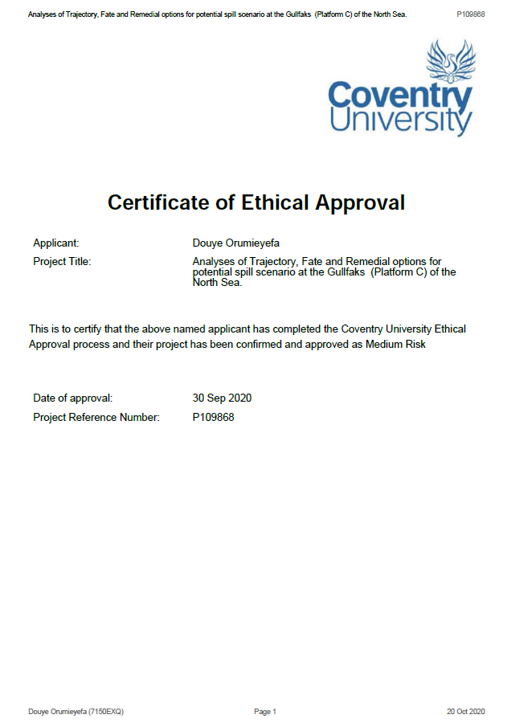

**APPENDIX 2: Ratio of viscosities of emulsion to starting oil (Fingas 2009)**

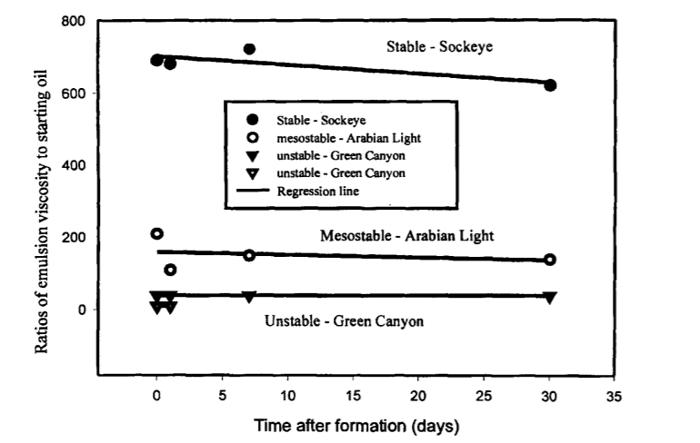

**APPENDIX 3: File Format for GNOME Standard Splot File Output**

Appendix 3.1: Format for Spill Specific Informatio**n**

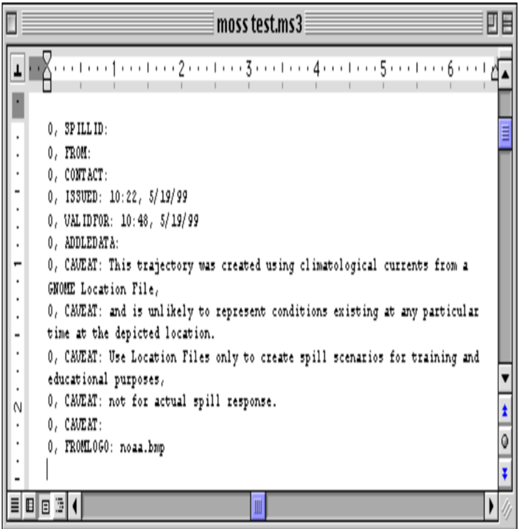

Appendix 3.2: File Format for Minimum Regret Splots

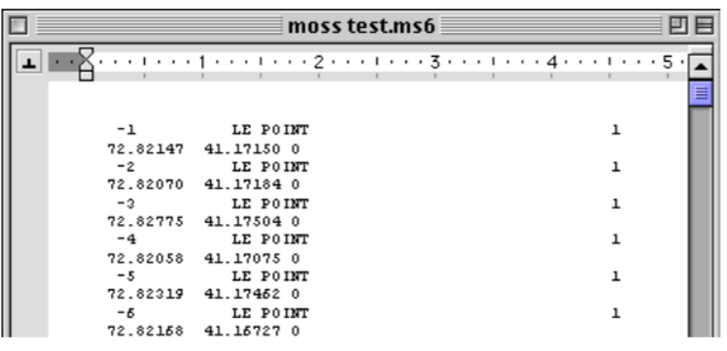

**Appendix 4: GNOME Settings for the Gullfaks C Spill**

Appendix 4.1: GNOME Modal Settings

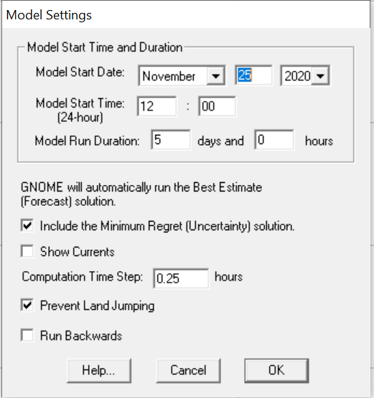

Appendix 4.2: GNOME Spill Settings

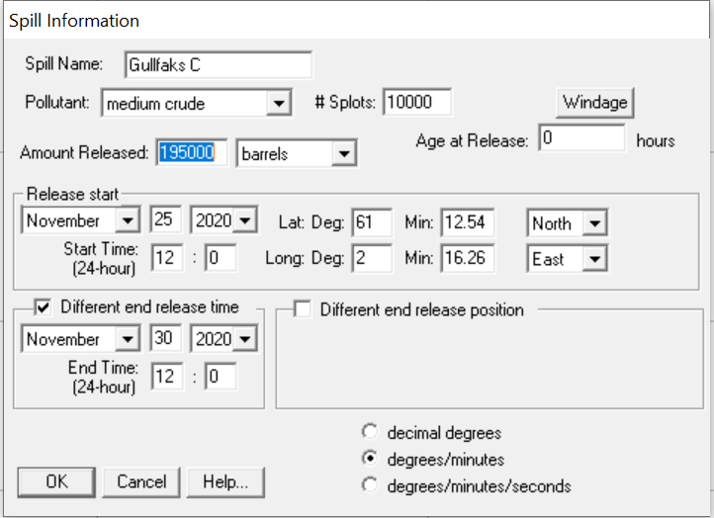

**Appendix 5: Data Structures for HYCOM (GOODS 2020)**

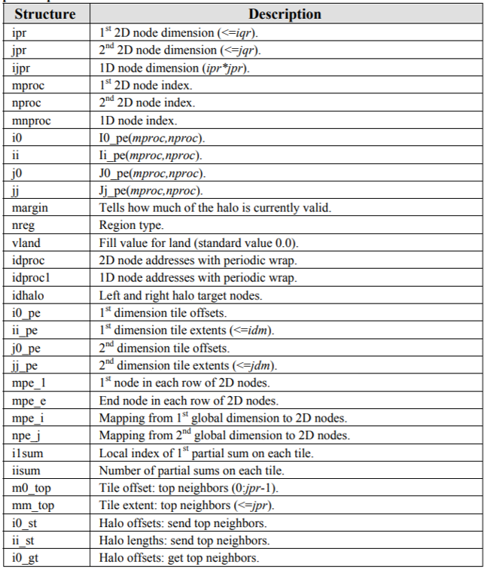

**Appendix 6: Prevailing Weathering Processes (Sebastiao and Guedes 1995)**

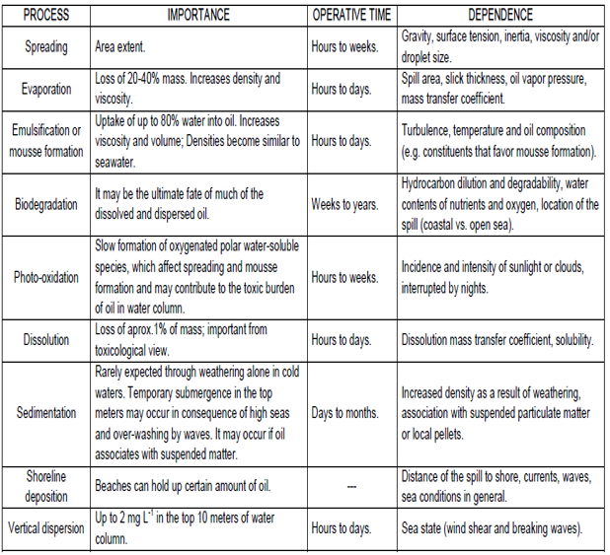

**Appendix 7: ADIOS2 Oil Budget**

Appendix 7.1: ADIOS2 Oil Budget during Summer

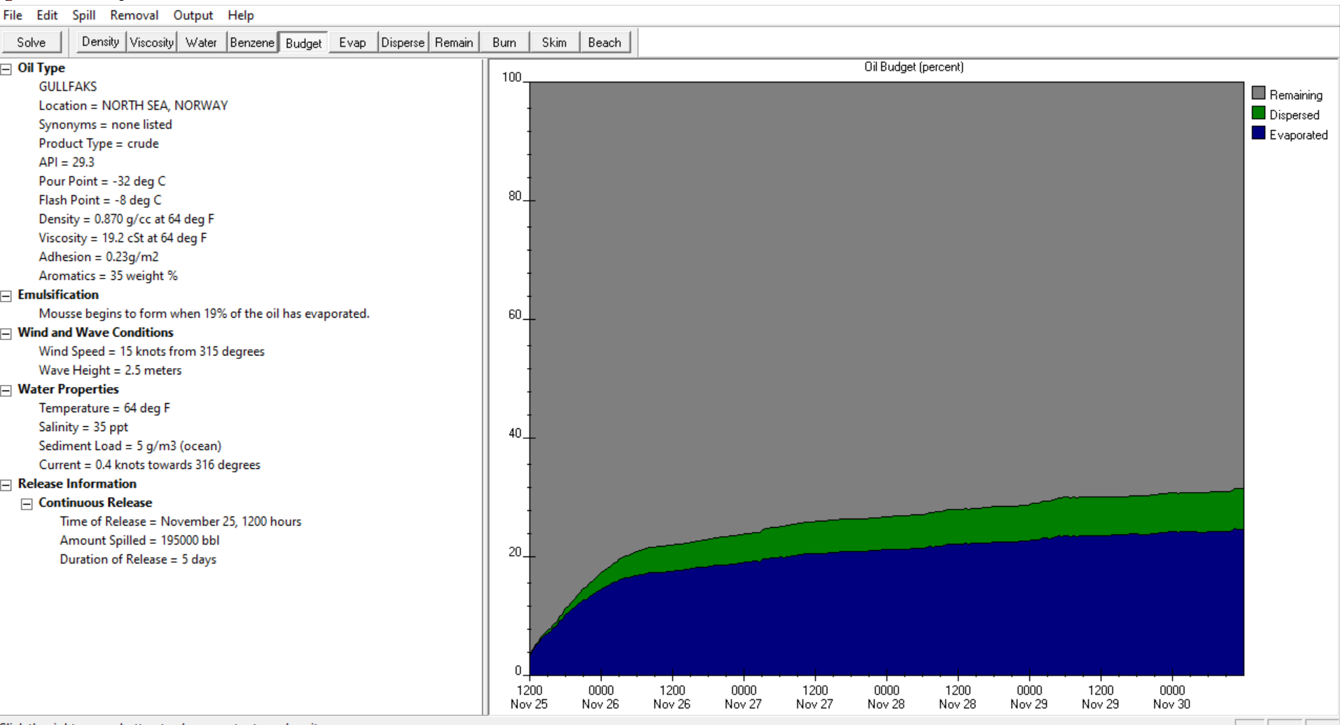

Appendix 7.2: ADIOS2 Oil Budget during Winter

